Report on Alumni Talk

Name of the Activity: Alumni Talk

Day & Date: 29/07/2026 Wednesday
Time: 11:00 am - 12.00 pm
Mode: Offline
Venue: S3
Participants: I B.com D,II B.com D,III B.com B & D
Chief Guest: Ms. Shruthi kumari.
Ms. Shruthi kumari mam has demonstrated remarkable dedication and perseverance in pursuing professional excellence.
She began their US CMA journey during their B.Com with the goal of building a strong foundation in finance and management accounting. While completing her graduation, she successfully cleared both parts of the globally recognized US CMA qualification.

Course of the Event:
The event commenced with a welcome speech by Shriya agastya, Later the chief guests of the event was welcomed, Ms. Shruthi Kumari. After that, Our esteemed alumnus, Ms. Shruthi kumari took over the stage. The speaker shared valuable insights about the CMA journey, examination pattern, preparation strategies, and career prospects. The session began with an introduction to professional courses and its focus on accounting, cost management, and financial decision-making. The speaker explained that pursuing these courses opens doors to various career opportunities such as Chartered accountant, Cost Accountant, Financial Accountant, Management Accountant, and Consultant. The alumni clarified students' doubts regarding their courses and recommended using HOCK's publications for exam preparation. Students were advised to practice MCQs regularly, attempt all the questions during preparation, and learn from their mistakes. The importance of taking mock examinations was highlighted, as they help students prepare effectively for the final examinations. Differences between the US CMA and Indian CMA qualifications were briefly discussed. Additionally, students were informed that short descriptive questions may also be asked in the examinations.
Some useful preparation tips shared during the session were:
•Take up mock tests as possible.
•Do not depend entirely on coaching classes.
•Develop a habit of self-study and consistent practice.
The alumni talk was highly informative and motivated students to explore CMA as a promising professional course. It provided practical guidance on exam preparation and career opportunities in the field of accounting and management.
Vote of Thanks was proposed by Ms. Navyashree ,expressing gratitude to the Chief Guest, the faculties, and students for gracing the event, and showing appreciation to the members of the association and the teachers who worked hard to make the event successful.

i. Photographs:

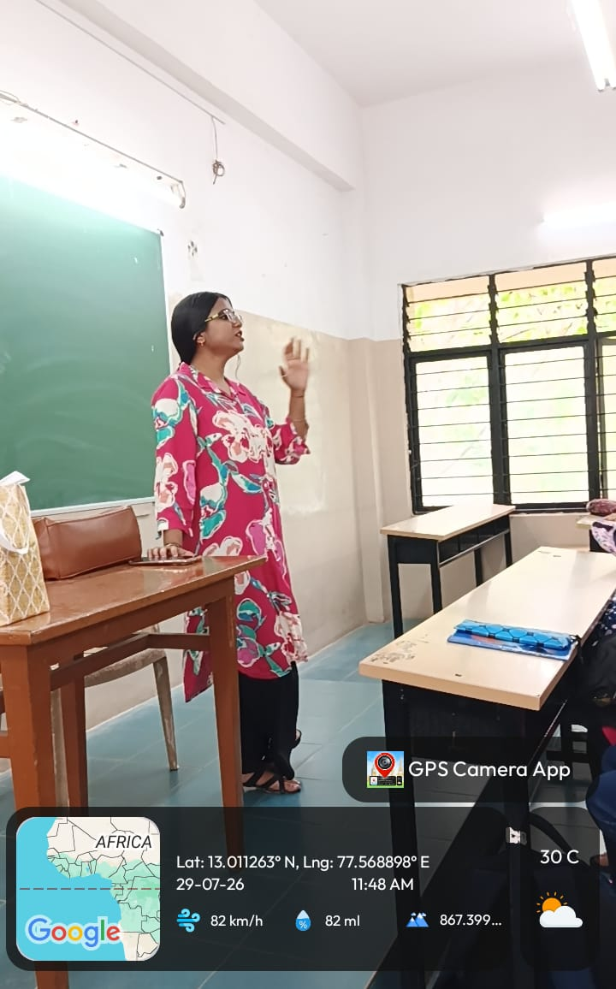
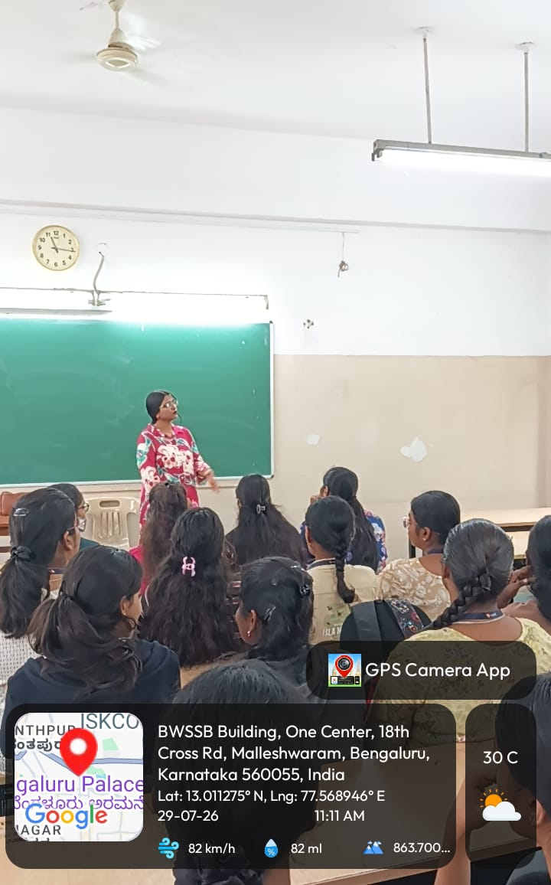

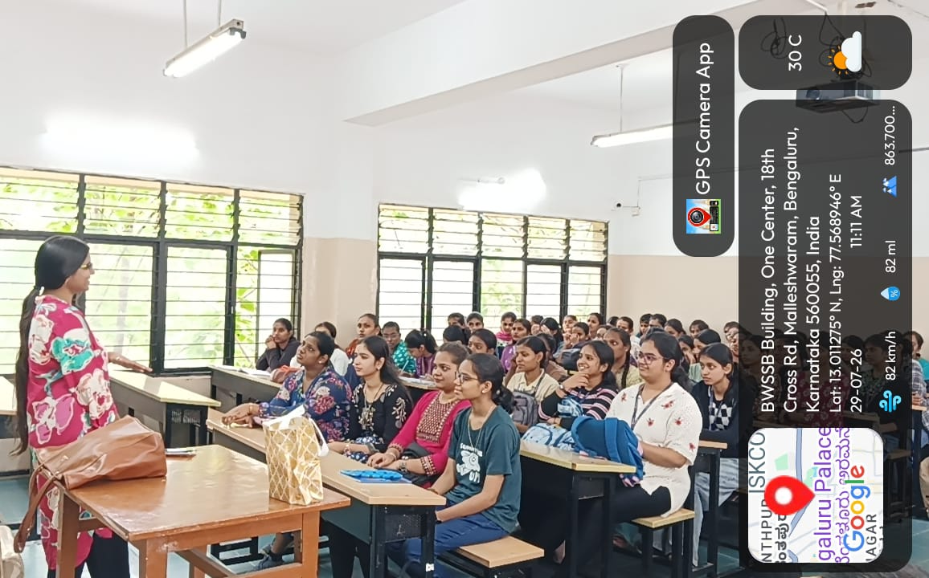

ii. Broucher:
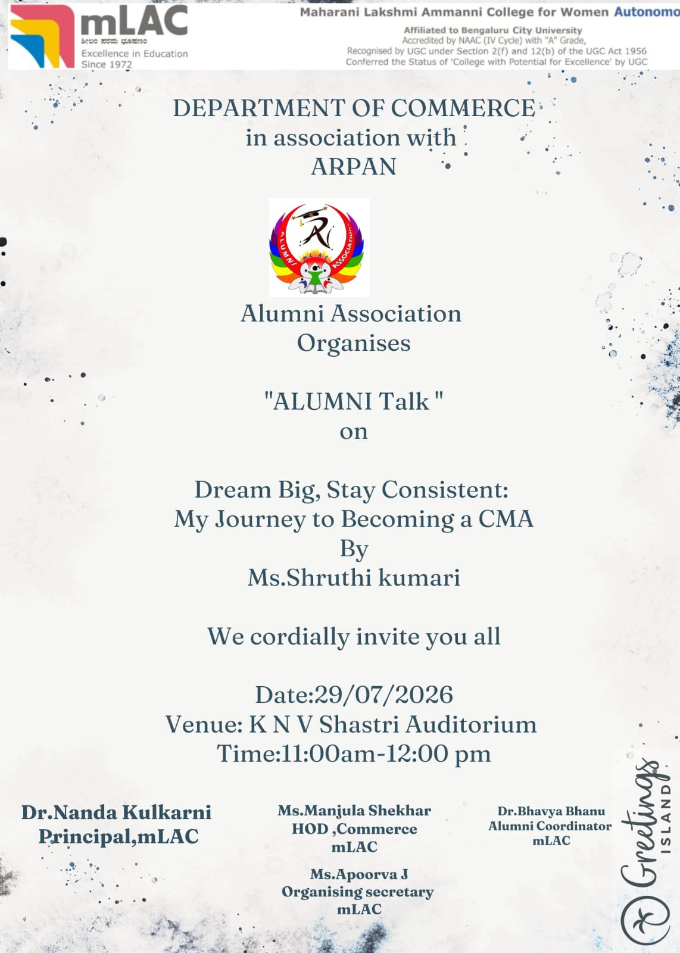

Students Feedback:

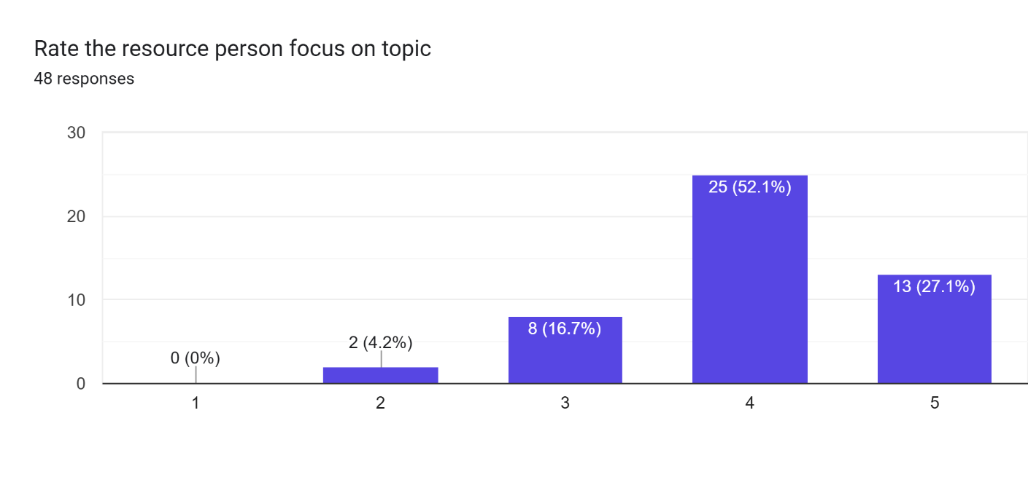
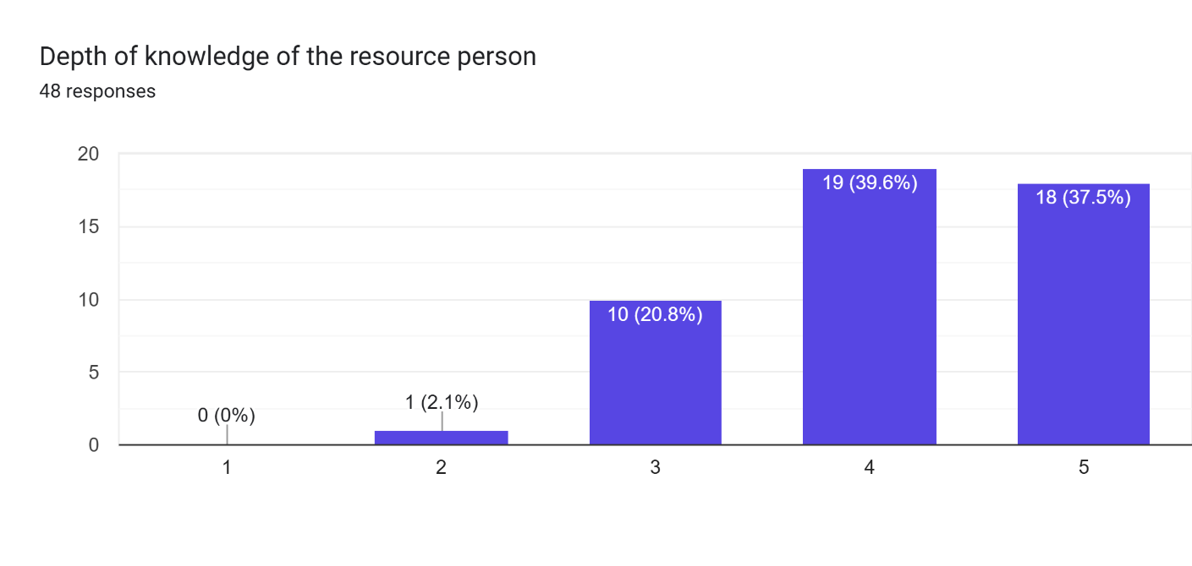
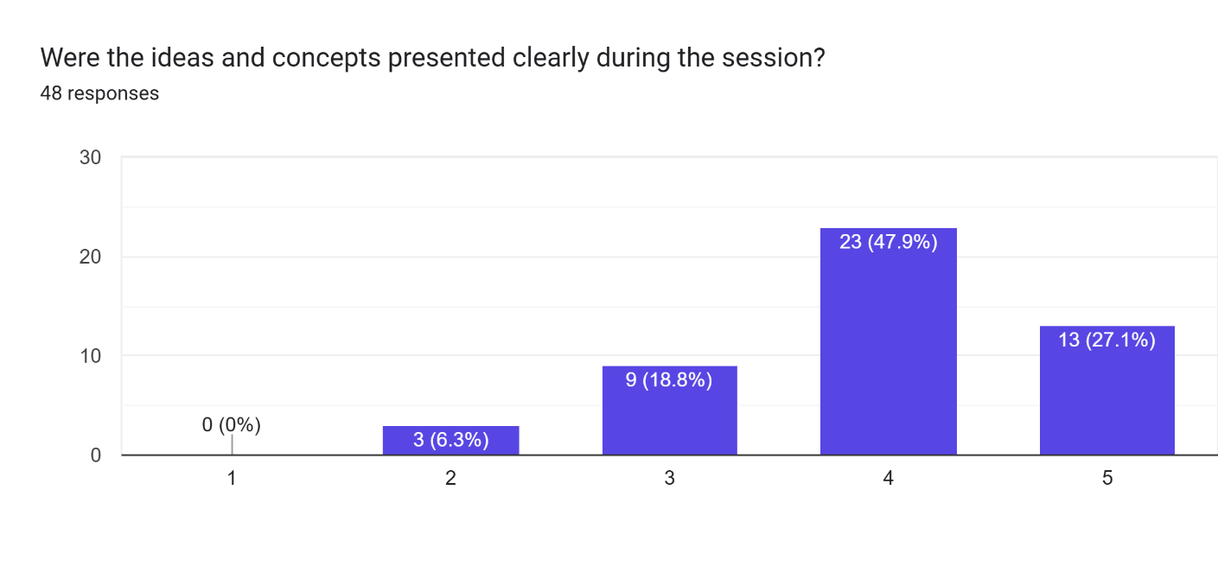
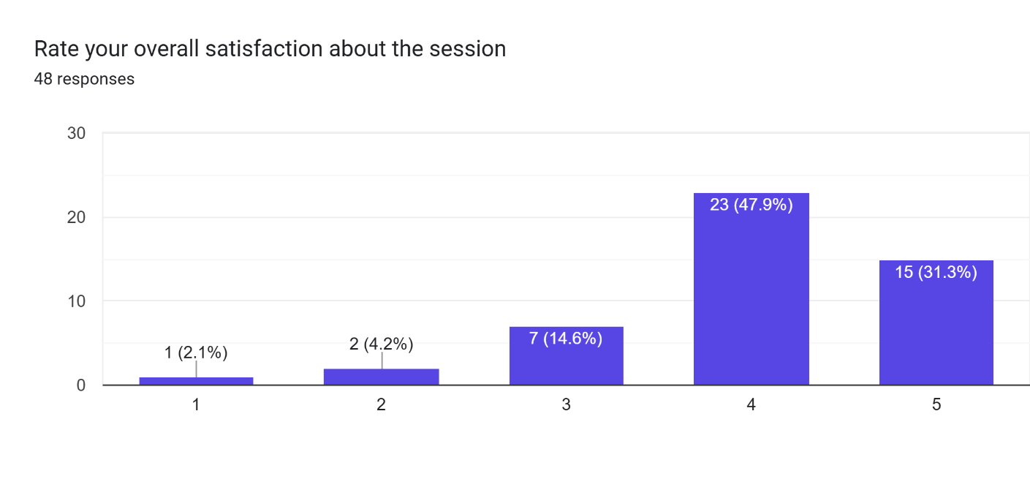

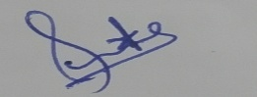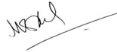

Organizing secretary Head of department Principal , mLAC
Commerce, mLAC Commerce, mLAC

