



CELL FOR SUSTAINABILITY
(An IQAC initiative)
REPORT ON INAUGURAL FUNCTION
With an intention to practice sustainability and bringing awareness, IQAC has initiated “Cell for Sustainability” at mLAC with the following objectives:
- To integrate environment and socially responsible practices into the campus ecosystem
- Bring awareness about sustainability by planning various activities in association with premier academic institutions and industries
- To meet the UN’s Sustainable Development Goals/Global Goals and implement them for the benefit of students, staff and public
In this regard, inauguration of the cell was held on 16.02.2026 at Dr. K.N. V. Sastri Auditorium which was attended by students and faculty members
Ms. Jyotsna Thimmaiah, set the context for the event and welcomed the dignitaries to the dais.
Ms. Aruna H.K., IQAC Coordinator welcomed the Dr. Nanda Kulkarni, Princiapl, mLAC; Mr. Venkatesh Raghavendra, Chief guest and Ms. Ashwini, environmentalist.
It was followed by inaugural address by Mr. Venkatesh Raghavendra, a Global Philanthropy Leader, Social Impact Strategist and Systems Innovator. He is a resource person to India’s Ministry of Finance, former advisor to the National Skill Development Corporation and consultant to the Government of Karnataka. He is entrusted with designing and delivering training and capacity-building initiatives for policymakers on innovation, public leadership, and intrapreneurship.
He spoke about sustainability practices in everyday life. He interacted with the students and gave message for the students to explore, experience and save the natural environment.
Ms. Ashwini who is working with the Safe Water Network under Project Vasundhara, spoke about her work which focuses on environmental sustainability and biodiversity enhancement through initiatives such as lake rejuvenation, soil conservation and active engagement with farmers to promote sustainable practices.
A short video on sustainable activities at mLAC aligning with UN’s SDG goals, was screened which highlighted the initiatives and efforts from mLAC fraternity. Followed by this demonstration of bioenzyme production using organic waste and composting was held by the students. This was guided by the faculty members Dr. Saraswati and Dr. Radhadevi.
Releasing of calendar of events was held highlighting the activities which are planned under this cell.
Dr. Nanda Kulkarni, Principal delivered presidential address. She emphasized that sustainability is not just a buzz word to be used but to be practiced by all. Simple mindful acts like switching off the lights when classrooms are empty, segregating the waste at source so on can have an impact in everyday life.
The program ended with vote of thanks by Ms. Devika, who thanked mLAC management, Principal and organizers - Ms. Sowmya Sastry, Ms. Madhushree, Ms. Nagaveni R., Dr. Usha T., Dr. Radhadevi for organizing this event.

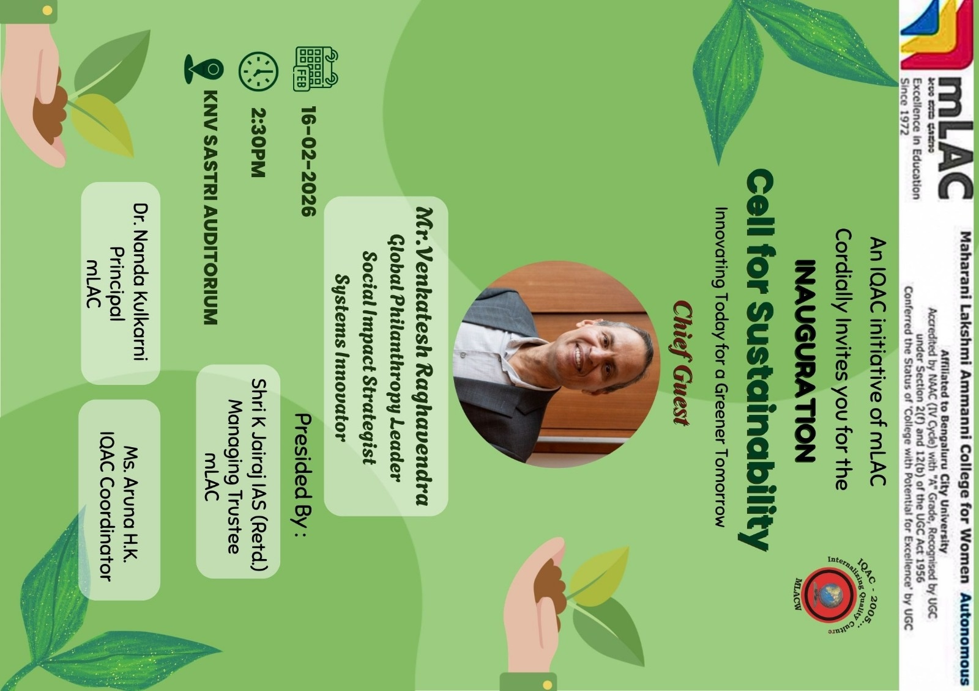

CELL FOR SUSTAINABILITY
(An IQAC initiative)
CALENDAR OF EVENTS
The importance of establishing “Cell for Sustainability” in the college has the following objectives:
- To integrate environment and socially responsible practices into the campus ecosystem
- Bring awareness about sustainability by planning various activities in association with premier academic institutions and industries
- To meet the UN’s Sustainable Development Goals/Global Goals and implement them for the benefit of students, staff and public

Sl.  No. | NAME OF THE EVENT | DATES
 | Green audit (environment, energy, water audit) | 26.02.2026
 | Student initiatives– (Bioenzyme production) | 14.03.2026
 | Awareness campaigns for students and public  (5Rs, Air Quality Index ) | 28.03.2026
 | Social entrepreneurship initiatives:  1. Gender equality  2. Sustainable marketing business ideas | 02.04.2026  27.04.2026
 | Launching of Add on courses (climate change/ disaster management/ business plan development/ block chain technology and its applications, vermicomposting, sustainability in tourism) | 06.07.2026
 | Seminar series and technical talk (climate change, innovations and new technologies in renewable energy, next generation technology for start-ups so on) to be organized by the departments | 15th - 30th July 2026
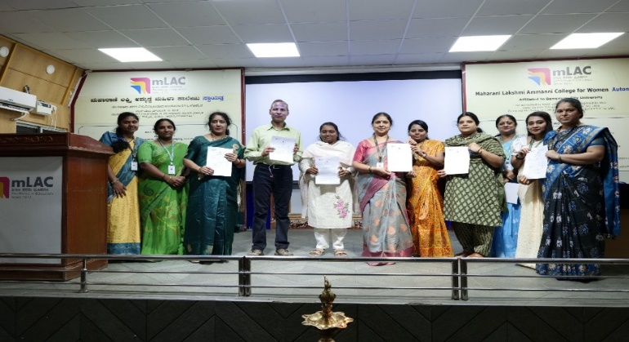
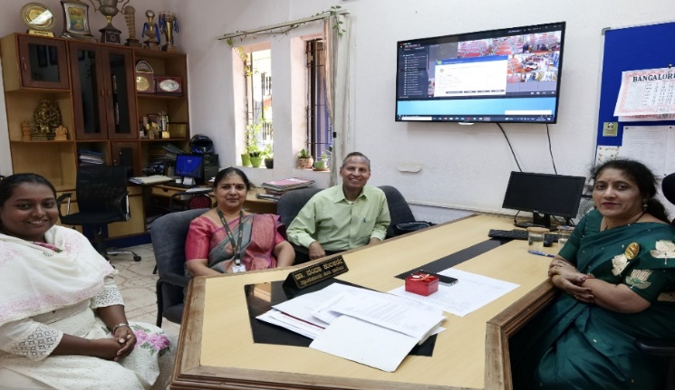
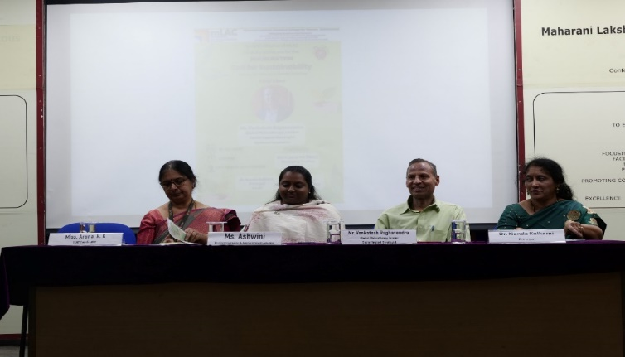
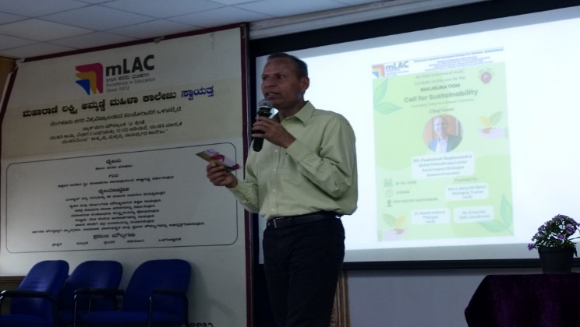
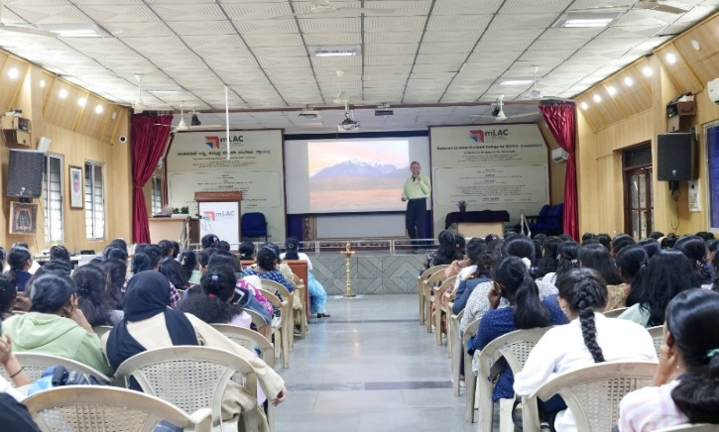
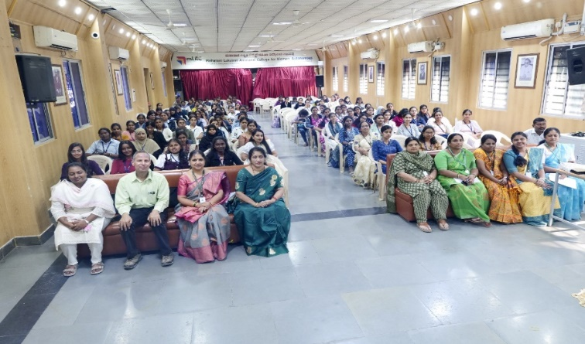
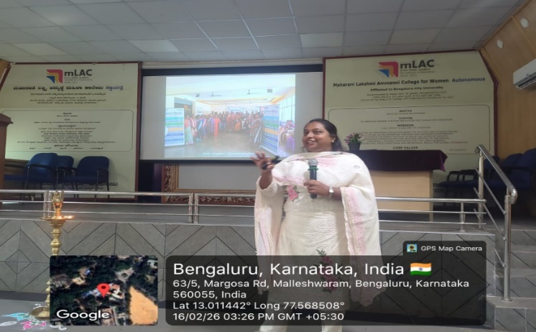
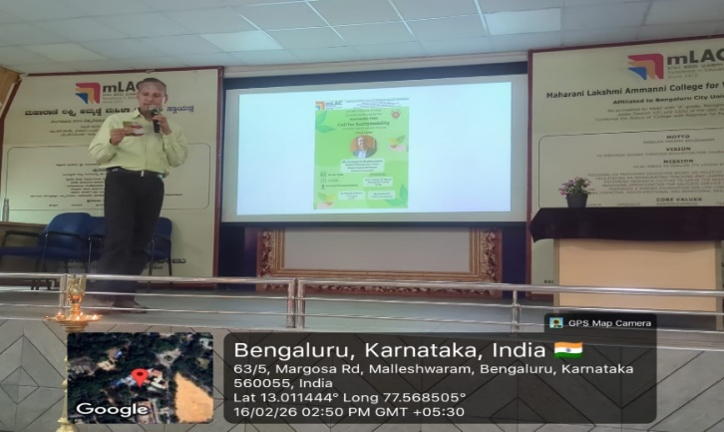

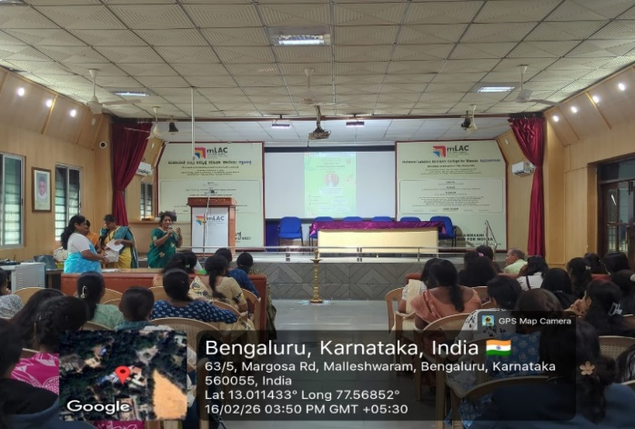

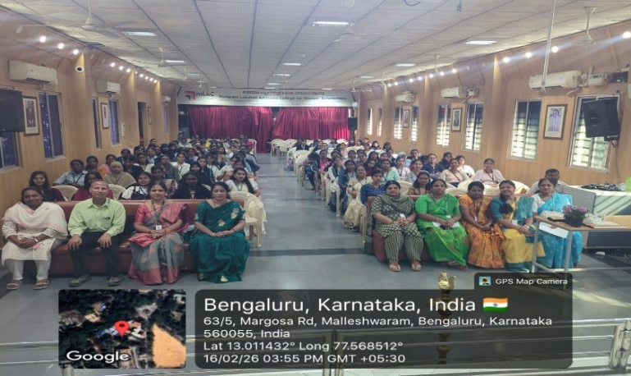

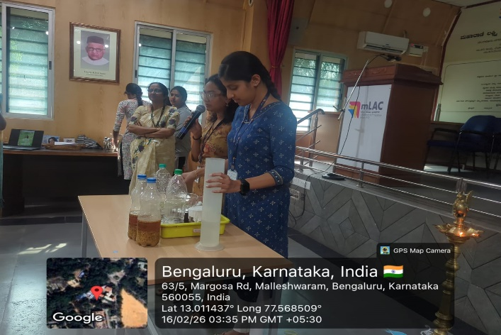

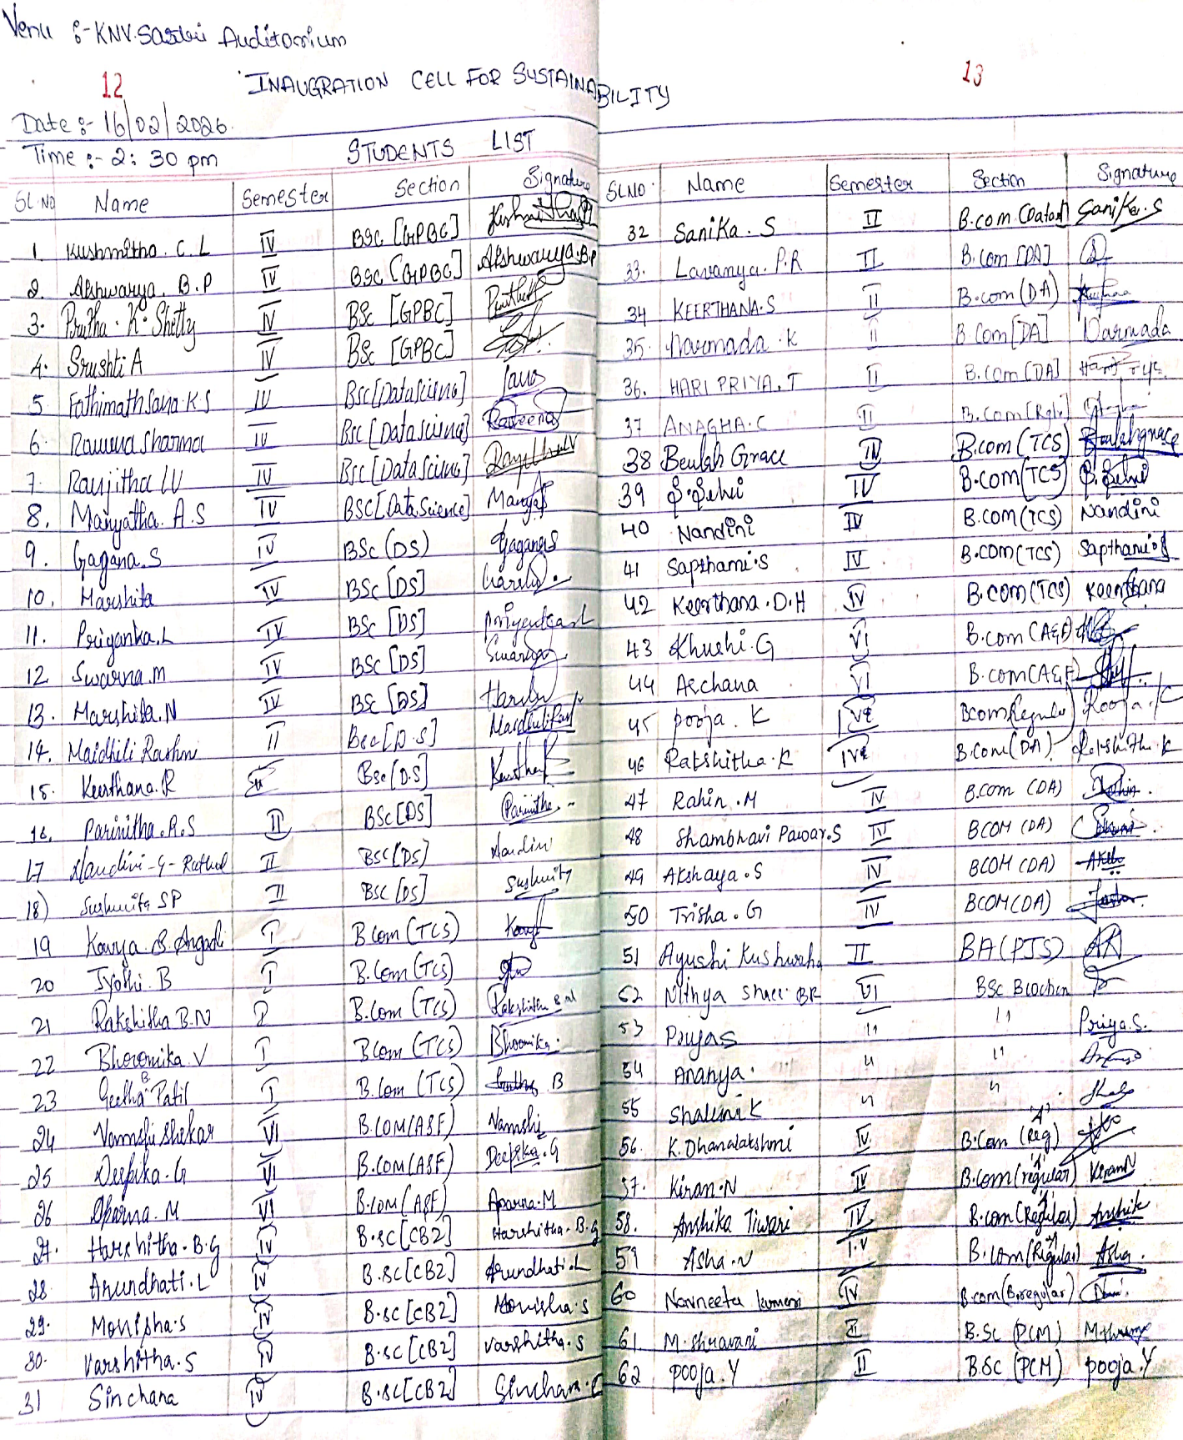
PARTICIPANTS LIST
