
Name of the activity: Inter – Class Commerce Fest, Malgama 2025-26.
Date & Day : 25th September, Thursday.
Mode: Offline
Venue: S1, S3, S6, Students’ Lounge & Auditorium.
No .of Participants: 76 Groups (188 Students)
Summary of the Activity:
The Akanksha Students’ Association organized a one – day Fest, MALGAMA (2025-26) , with the theme ‘Sustainovate 2050’ ‘Where Sustainability meets Innovation through Commerce”.
Sustainability means using resources in a way that meets our current needs without harming the ability of future generations to meet their own needs. The event truly reflected the spirit of MALGAMA by promoting talent, innovation, and collaboration among students.
We had all three years of B.Com participate in large numbers making it a grand success and a learning experience for all students. 4 events were conducted this year –
- Pitch Perfect – ‘A Vision where Creativity meets Sustainability’:
13 teams of 2 members each, participated in this event, which provided a meaningful platform for students to combine creativity with communication, fostering both artistic and intellectual growth. It consisted of 2 rounds –
Round 1: Posterize – A Poster Making Competition aimed at encouraging creativity, innovation, and communication skills among the participants, provided a platform to present their ideas visually and persuasively, aligning with the theme of the fest. Students created posters within the allotted time using their choice of materials and the judge selected the most unique ones for round 2.
Round 2: Showcase – A Presentation Round that focused on enhancing students’ ability to pitch ideas effectively. The event gave participants an opportunity to showcase not only their creativity but also improved their confidence, communication, and persuasive skills. Each participant/team presented their ideas using slides within the allotted time. Judges interacted with participants, testing clarity and depth of understanding The event was graced by our esteemed judge, Ms. Vrinda Bilgi. The judge provided constructive feedback, encouraging students to present their ideas effectively and commending their efforts.
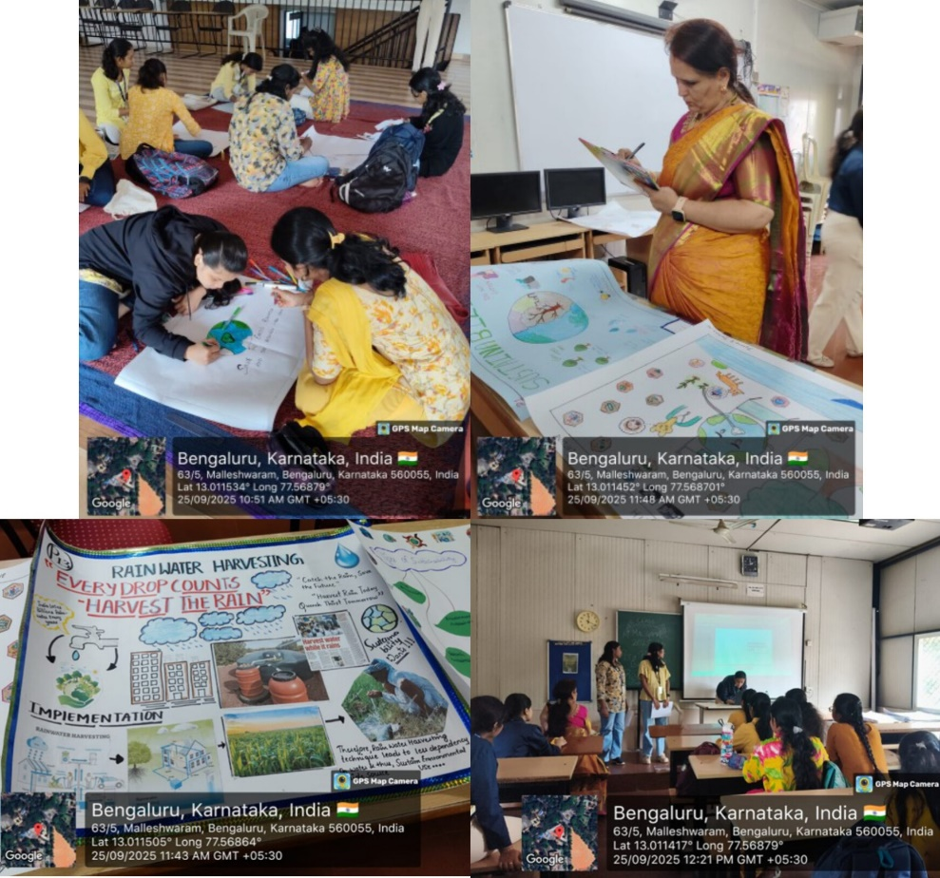
- Ecobiz – ‘Innovate, Compete, Sustain’:
36 teams of 3 members each, participated in the event, who were enthusiastic, and the quiz not only tested their awareness but also inspired them to think critically about sustainability.
In keeping with the theme of sustainability, the entire event was organized in a paperless manner using Google Forms and digital displays, thereby promoting eco-friendly practices while ensuring a smooth conduct of the rounds. The competition featured three progressive rounds, each with its own focus and level of challenge –
Round 1: The Green Filtert – Conducted through Google Forms, this round tested participants’ fundamental awareness of sustainability through multiple-choice questions. It served as the elimination stage, filtering teams for the next level.
Round 2: Ecovision – This round highlighted logos, taglines, and practices of companies promoting sustainable development. It emphasized practical knowledge and global perspectives on sustainability, encouraging students to connect classroom learning with real-world practices.
Round 3: The Green Sprint – “Quick Minds, Fast Answers” - The grand finale was conducted on stage with rapid-fire, visual-based, and situational questions displayed on the screen. This interactive format kept both participants and the audience highly engaged, especially with PU students actively joining in the excitement.
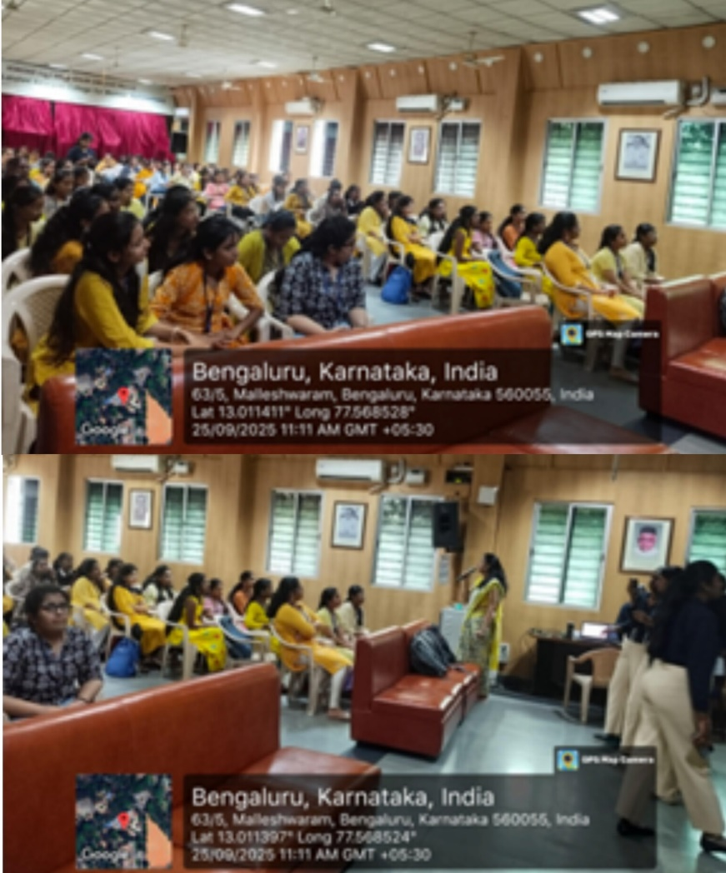
- Inno – Vision – ‘Innovate, Launch, Lead’:
18 teams of 2 members each, participated in the event, an innovative and knowledge-driven event encouraging students to come up with creative and eco-friendly entrepreneurial solutions for present and future challenges. The competition aimed to promote awareness about sustainability, nurture problem-solving skills, and provide a platform for students to showcase their ideas in a professional setting.
Round 1: Genesis – In round 1, participants underwent a Question & Answer session, to test their fundamental knowledge of sustainability, business strategies, and entrepreneurship. This round helped assess the participants’ conceptual understanding and ability to think critically under pressure. This gave a picture about how much they knew about entrepreneurship and current affairs in business.
Round 2: Voice your Vision – Shortlisted teams advanced to the Presentation Round, where they presented their sustainable business plans through a presentation. Each team showcased innovative business models with a focus on environmental, social, and economic sustainability. The presentations were evaluated based on creativity, feasibility, clarity, and alignment with sustainability goals. The event was graced by the esteemed judge Ms. Lalitha Panchanathan Ma'am. The judge actively engaged with the participants by asking insightful and thought-provoking questions related to their presentations. Students demonstrated remarkable creativity in proposing eco-friendly and socially responsible business solutions.
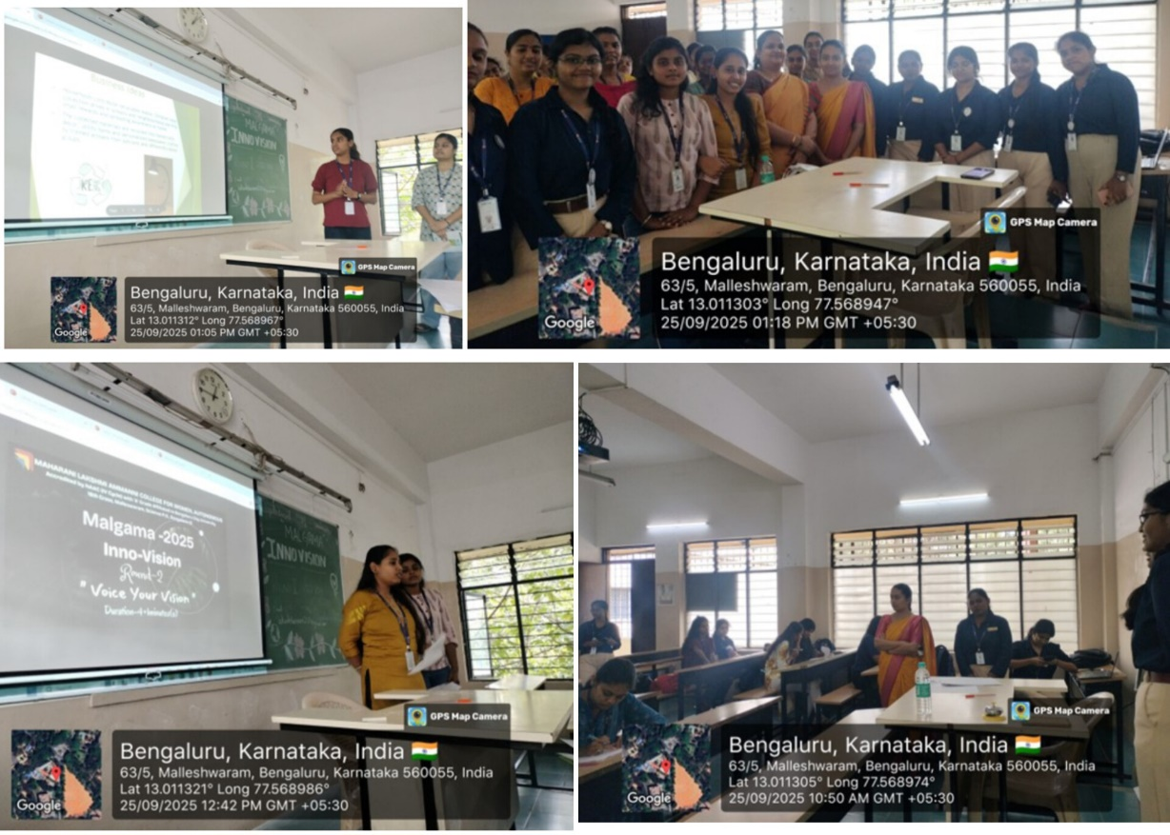
- Prosperia – ‘One Small Act at a Time, Big Impact’:
10 teams of 2 members each, participated in the event based on CSR theme, to create awareness and encourage students to showcase their creativity and responsibility towards society. The event comprised of two competitive rounds –
Round 1: Green Vision – Students presented their innovative CSR ideas through PowerPoint presentations. Criteria for judgment included content accuracy, creativity & innovation, and presentation skills. The presentations highlighted various CSR initiatives such as environmental sustainability, education, health, and community development.
Round 2: CSR Creative Campaign – Participants created posters reflecting CSR concepts and innovative solutions. Judgment criteria included creativity, originality, relevance to CSR, and presentation. Students used visuals and slogans to communicate their messages effectively.
The rounds were evaluated by our esteemed judge, Ms. Arushi.A.Singh, based on the above-mentioned criteria. The CSR activities conducted in Inter-class fest successfully engaged students in meaningful learning experiences. The event not only enhanced their understanding of corporate responsibility but also fostered creativity and teamwork.
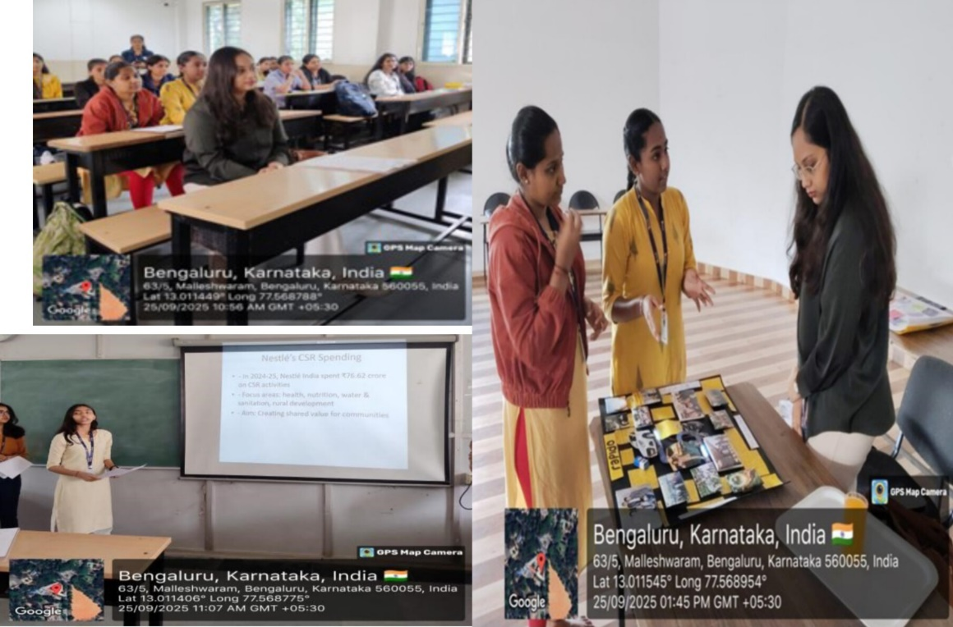

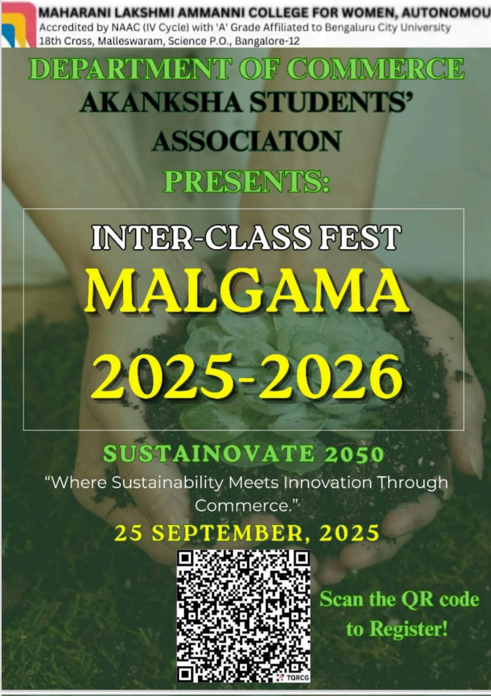

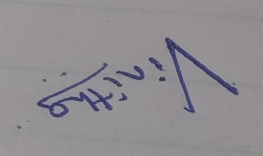
Organising Secretary Head of the Department Principal
Ms. Vinitha Raghavan Assoc. Prof. Manjula Shekar Dr.Sharmishta Dutta

