Report on Alumni Talk

Name of the Activity: Alumni Talk

Day & Date: 30/10/2026 Wednesday
Time: 11:00 am - 12.00 pm
Mode: Offline
Venue: S2
Participants: I B.com A & I B.Com D
Chief Guest: Ms. Ananya K A.
Ananya K is a B.Com graduate from Maharani Lakshmi Ammanni College for Women, Bengaluru. She began her career through campus placement at “Empower”, gaining corporate experience. She then explored entrepreneurship by managing a food business, where she learned about business operations, people management, and decision-making.
She later returned to the corporate world with “Eurofins IT Solutions “and now works closely with a founder on the launch of a jewellery brand. Her journey reflects a willingness to take risks, learn from different experiences, and grow.

Course of the Event:
The event commenced with a welcome speech by Lekha J G , Later the chief guest of the event was welcomed, Ms. Ananya K A. After that, our esteemed alumnus, Ms. Ananya K A, took over the stage. The speaker shared valuable insights about She shared her experiences, challenges and the steps she took to start her entrepreneurial journey.
The session helped to understand that entrepreneurship is not only about having a business idea, but also about having confidence, taking risks and learning from failures. Her personal experiences gave us a practical understanding of the journey of an entrepreneur.
Overall, the session was interesting, motivating and useful for students. It encouraged them to think creatively and consider entrepreneurship as a possible career opportunity in the future. The key takeaway is that there is no single path to success every experience contributes to growth.

Vote of Thanks was proposed by Ms. Leha J G,expressing gratitude to the Chief Guest, the faculties, and students for gracing the event, and showing appreciation to the members of the association and the teachers who worked hard to make the event successful.

- Photographs:

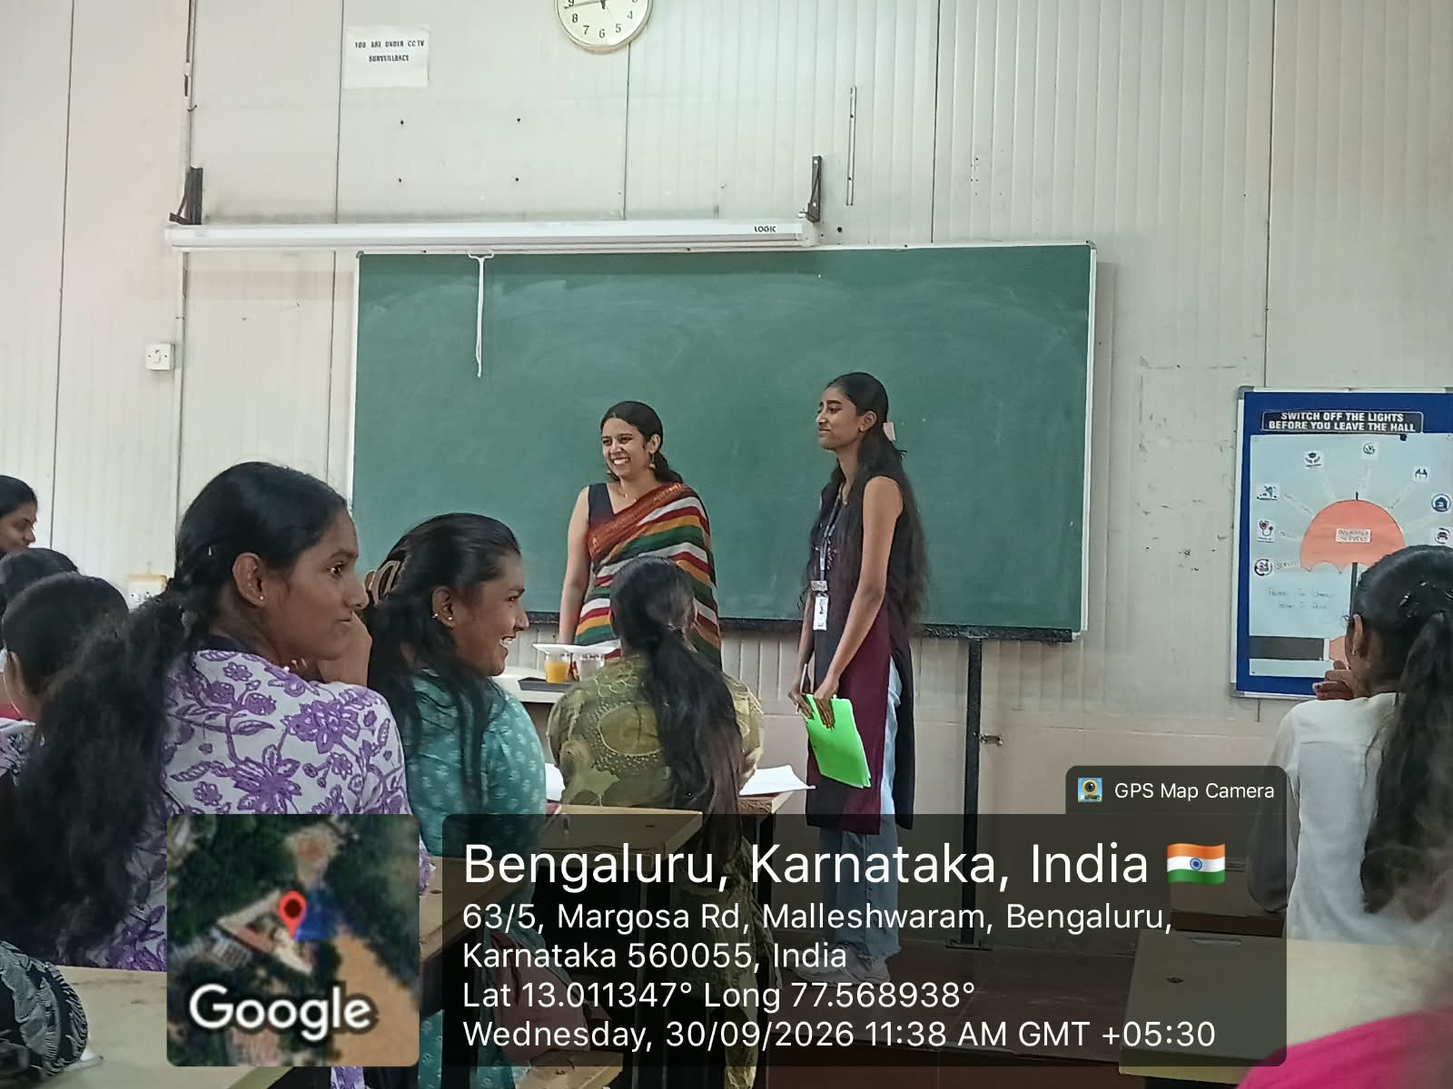
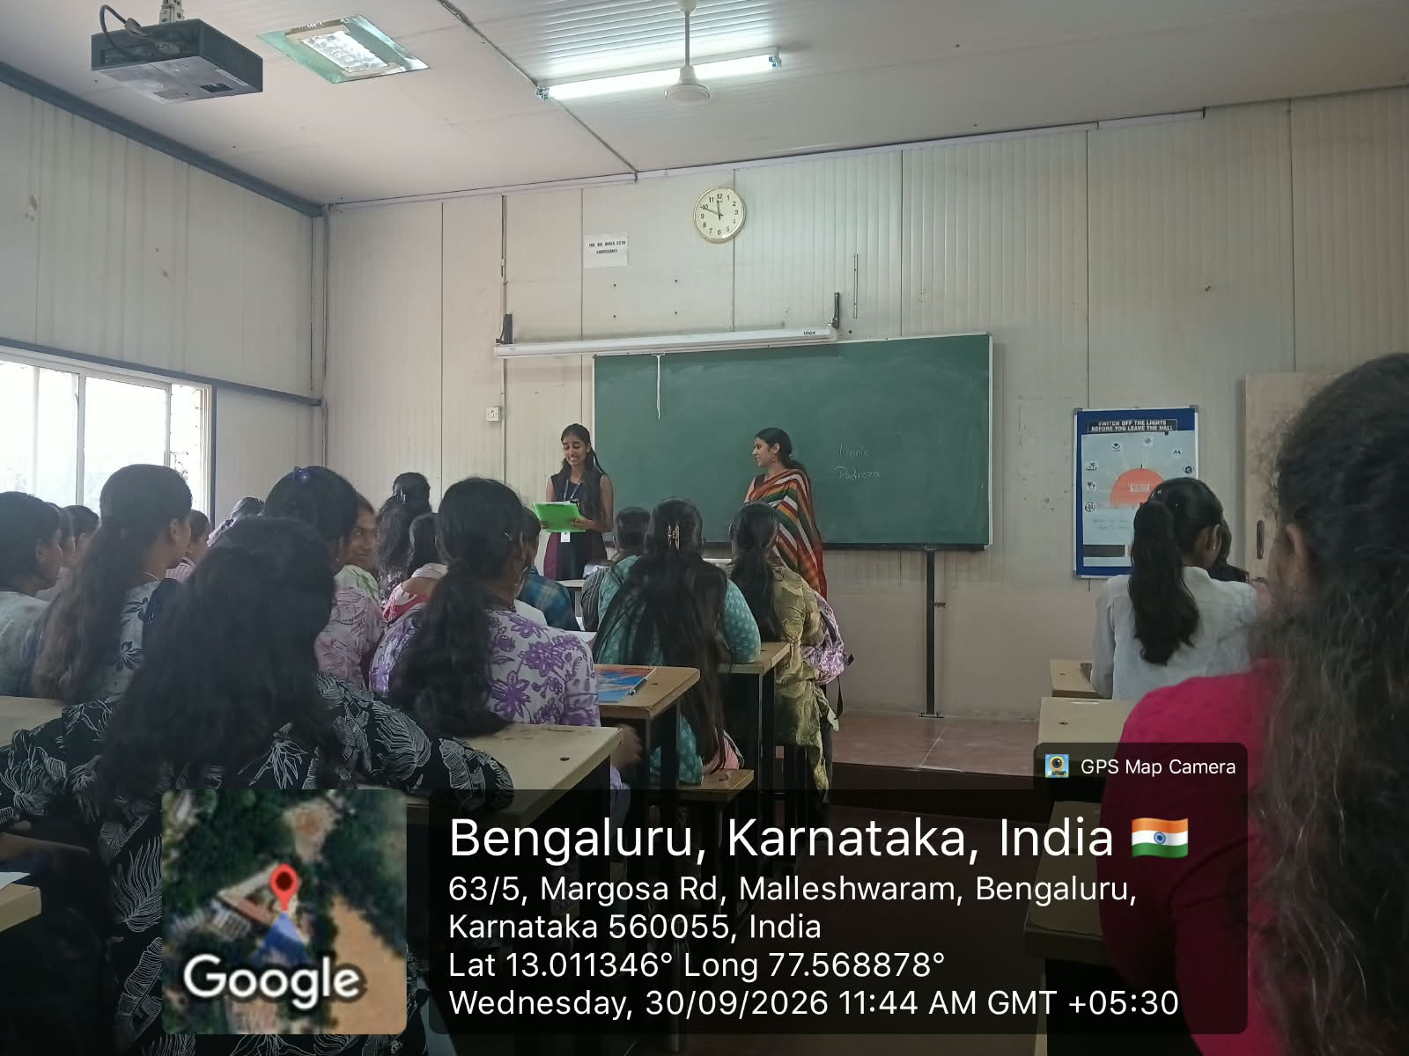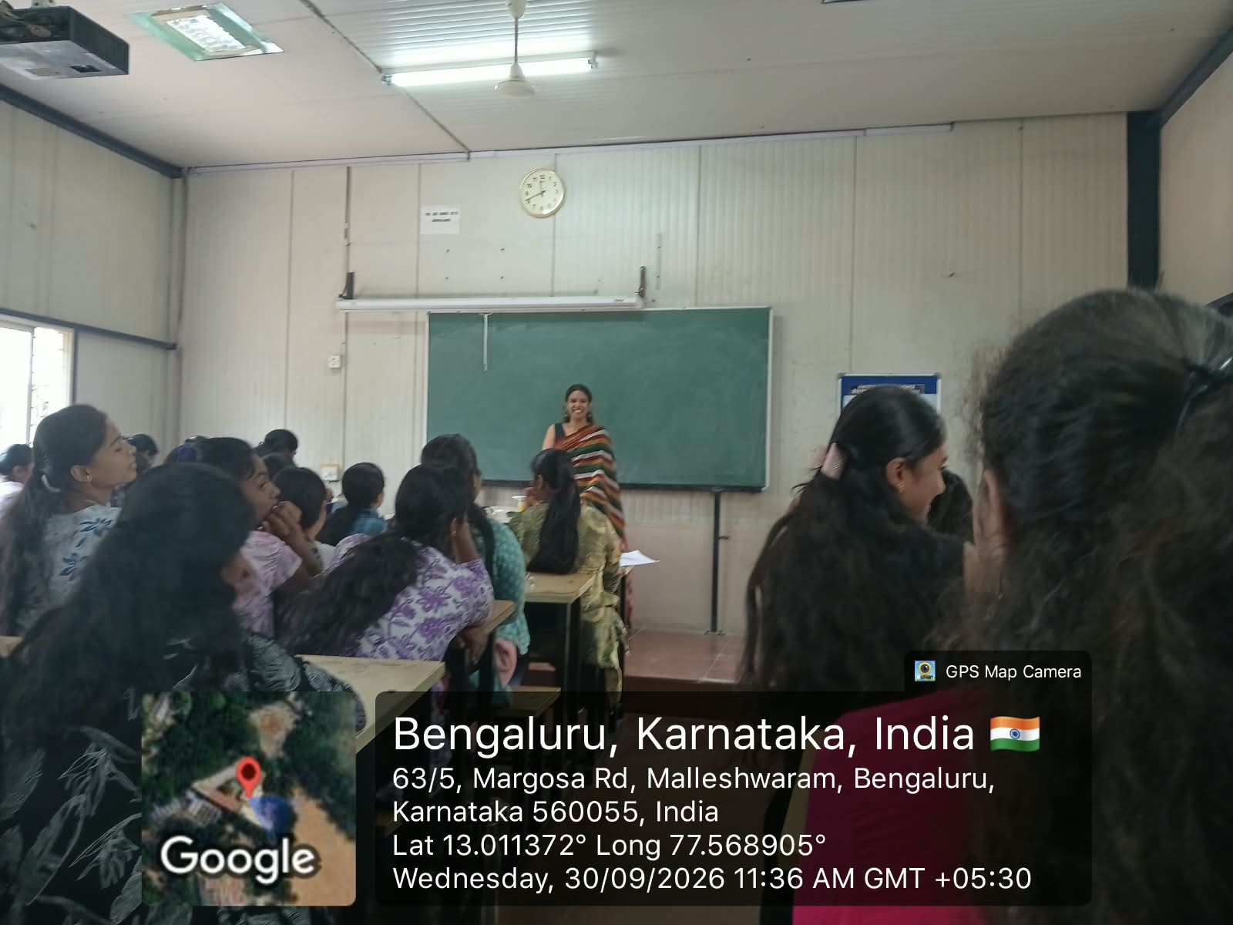

ii.Broucher
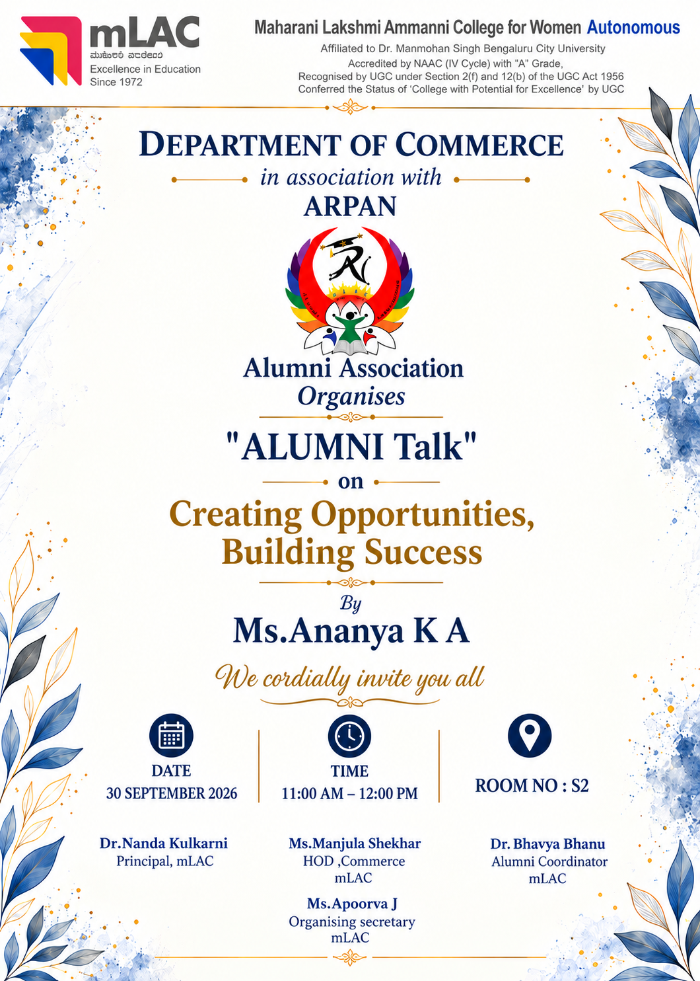
- Students Feedback:

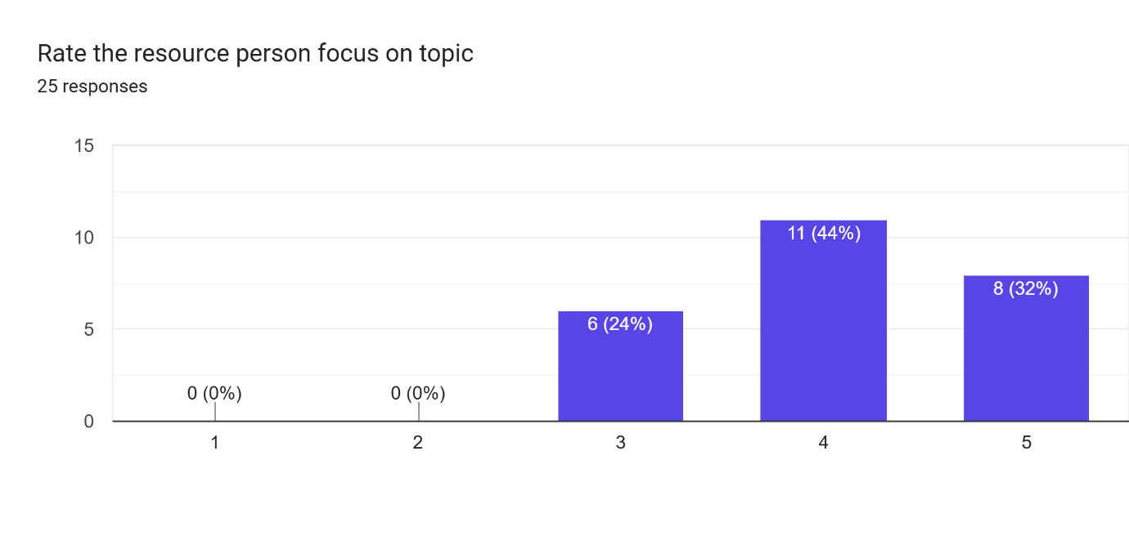
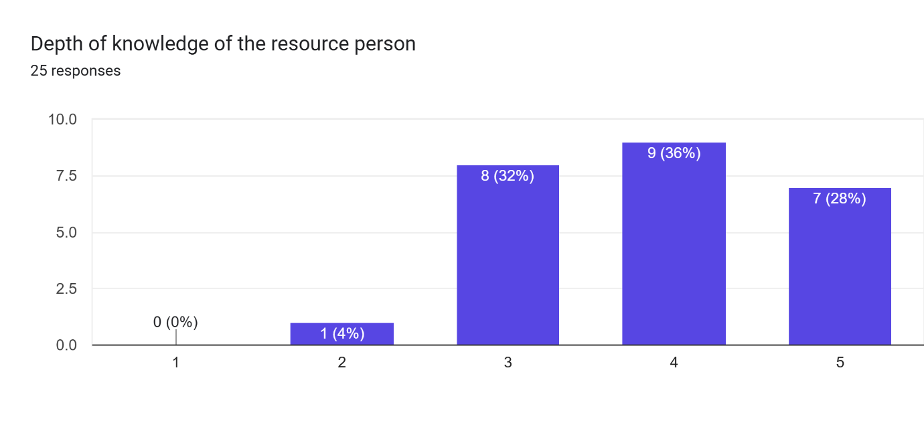
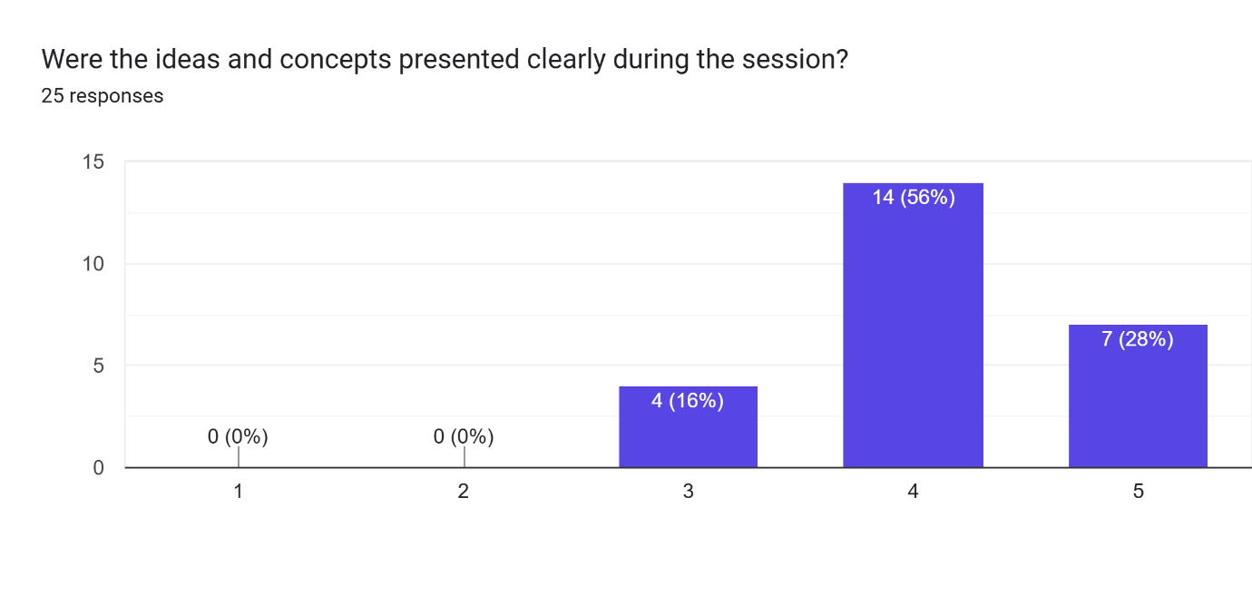
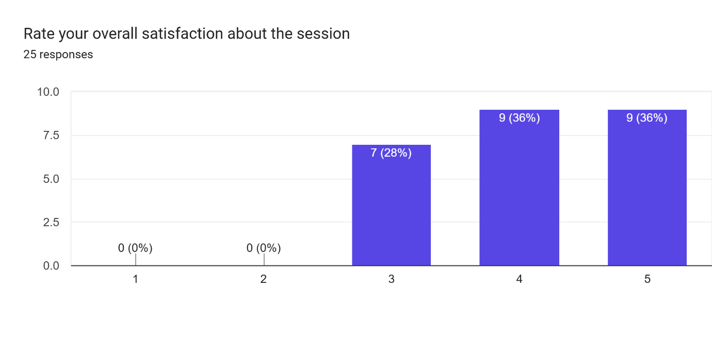



Organizing secretary Head of department Principal , mLAC
Commerce, mLAC Commerce, mLAC

