Report on Webinar

Name of the Activity: Webinar
Title of the event: Money Matters: Understanding the Basics of Finance
Day & Date: 04-08-2026
Time: 4:00 to 5:00 PM
Mode: Online
Resource Persons: Mr. Rahul
No. of Participants/ Beneficiaries: I B.Com Students
Brief summary of the activity:
The Department of Commerce organized a webinar on Money Matters: Understanding the Basics of Finance on 4th August 2026, from 4:00 PM to 5:00 PM through Google Meet for I B.Com students. The session was conducted by Mr. Rahul, who provided students with an introduction to fundamental financial concepts and the importance of financial awareness. The webinar focused on helping students understand basic money management, financial planning, and the significance of making informed financial decisions. The session also encouraged students to develop responsible financial habits and build a strong foundation for their future financial well-being. Overall, the webinar was informative and provided students with useful insights into managing and understanding finances effectively.
Attachments:
Invitation:
Feedback:
Geotagged Photos:

Invitation
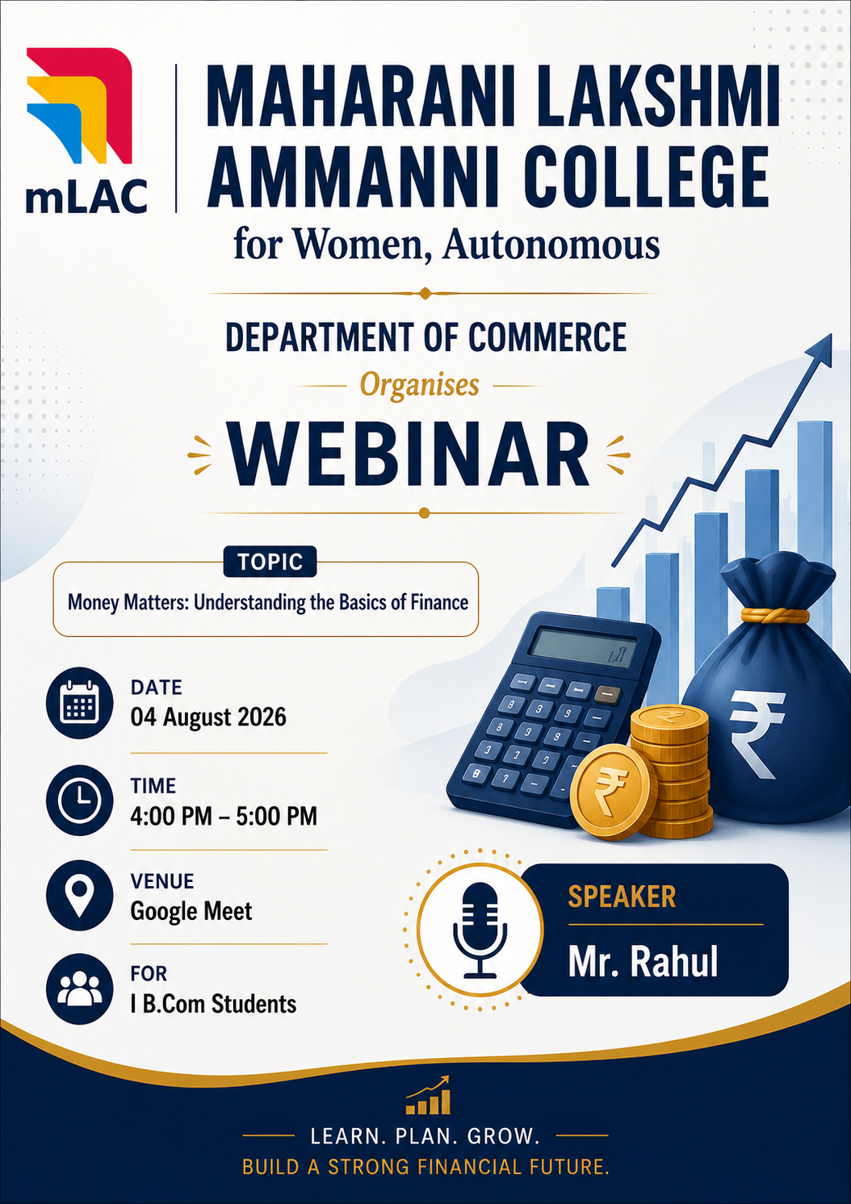

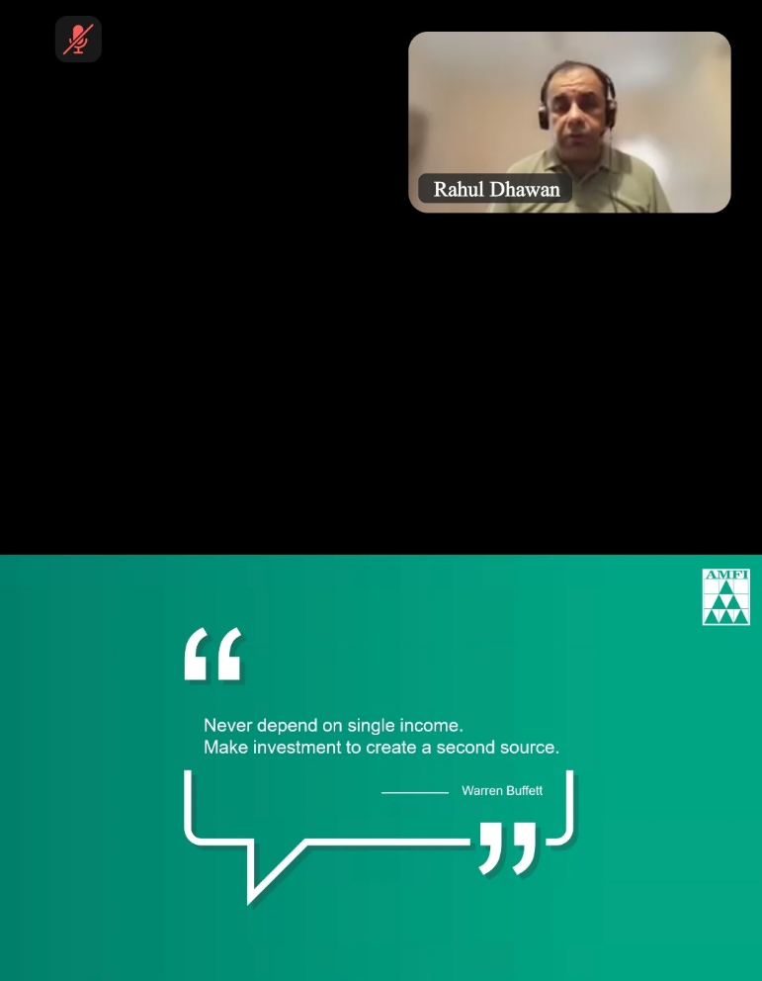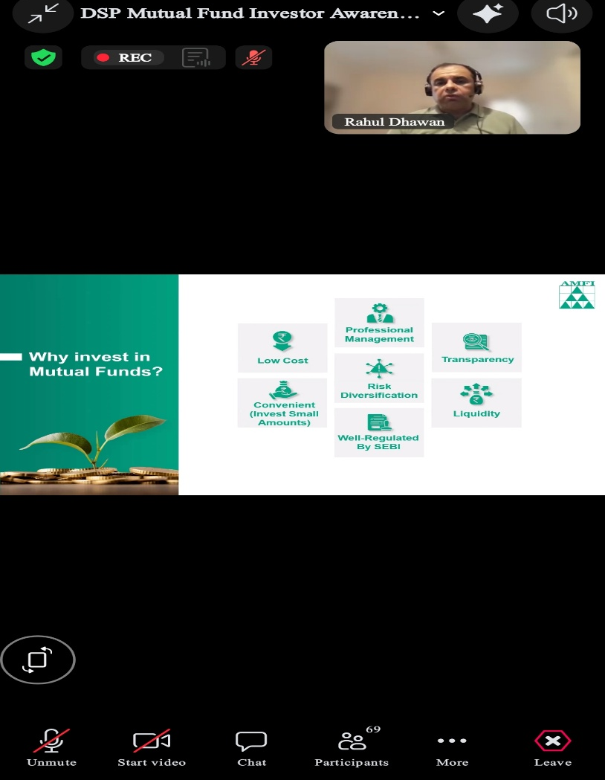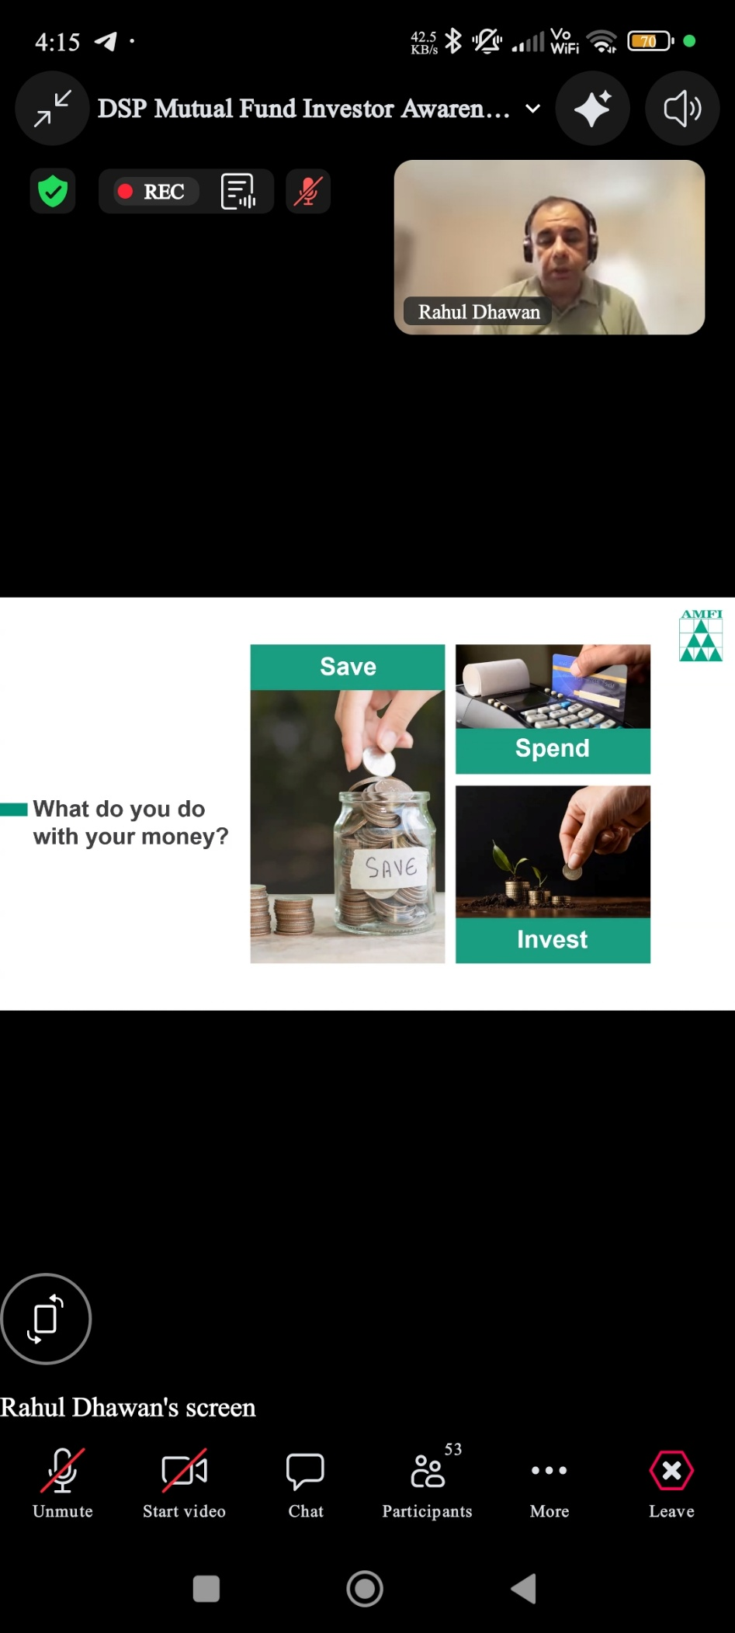

Student’s Feedback
