Report on Webinar

Name of the Activity: Webinar
Title of the event: Careers in Investment Banking
Day & Date: 14-08-2026
Time: 4:00 to 5:00 PM
Mode: Online
Resource Persons: Mr. Nilesh Saraswat & Mr. Vishal Bhojani
No. of Participants/ Beneficiaries: III B.Com Students
Brief summary of the activity:
The Department of Commerce organized a webinar on “Careers in Investment Banking” on 14th August 2026, from 4:00 PM to 5:00 PM via Google Meet for III B.Com students. The session featured Mr. Nilesh Saraswat and Mr. Vishal Bhojani as speakers. The webinar aimed to provide students with an understanding of career opportunities in investment banking, its various functions, and the skills required to build a career in the field. The speakers shared valuable industry-oriented insights and helped students understand the professional scope and career pathways available in investment banking. The session also encouraged students to explore the financial services sector and develop the knowledge and skills required for a successful career. Overall, the webinar was informative and provided students with useful exposure to the investment banking profession.
Attachments:
Invitation:
Feedback:
Geotagged Photos:

Invitation
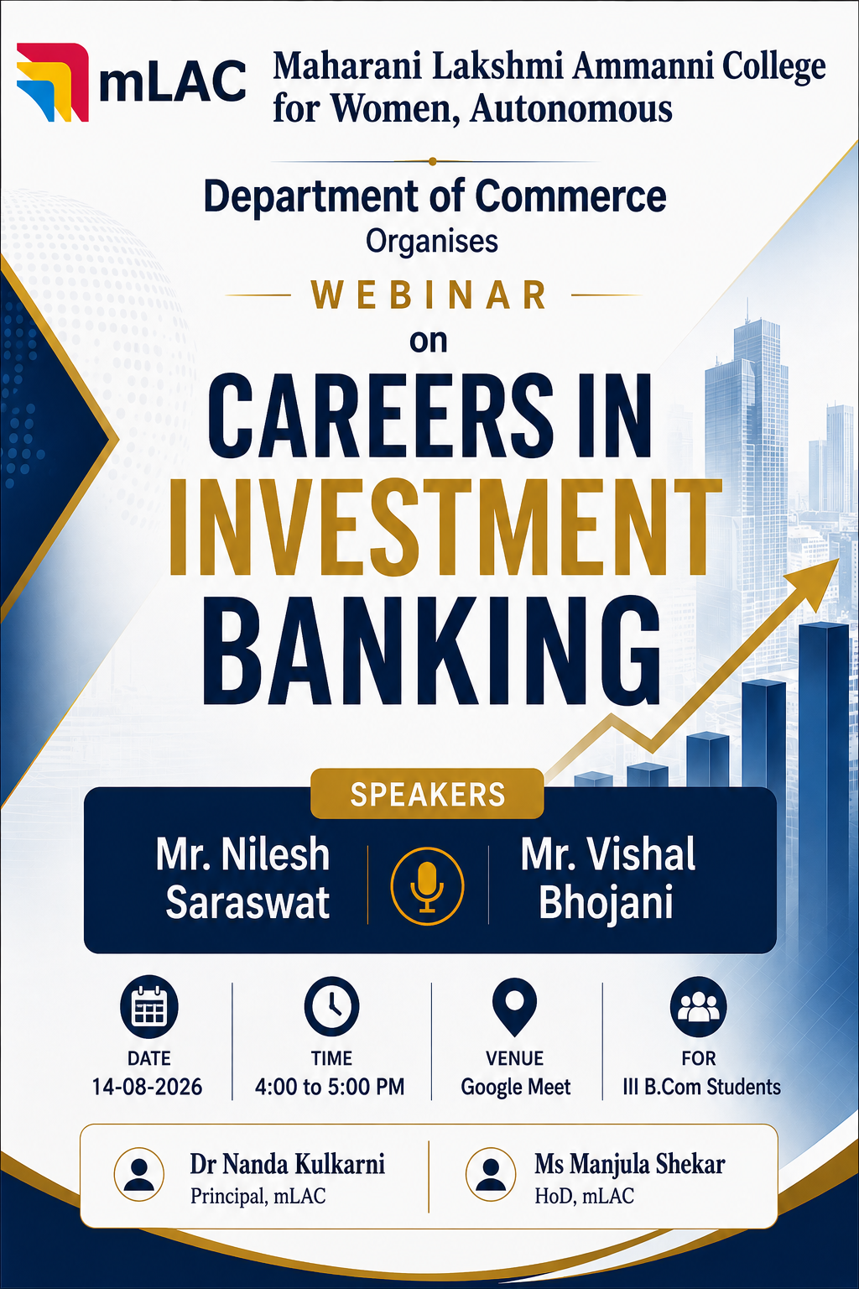
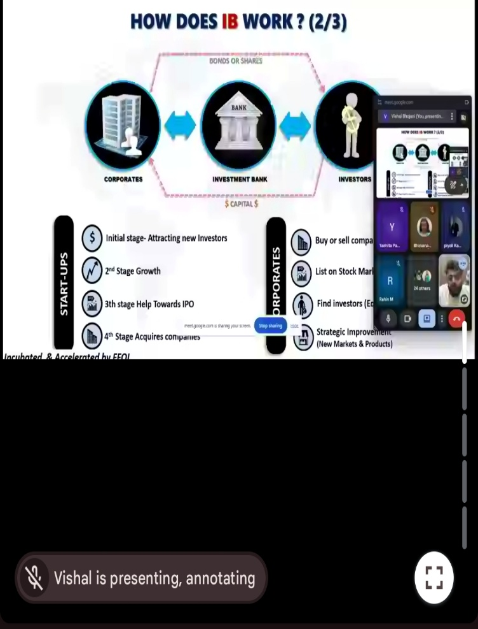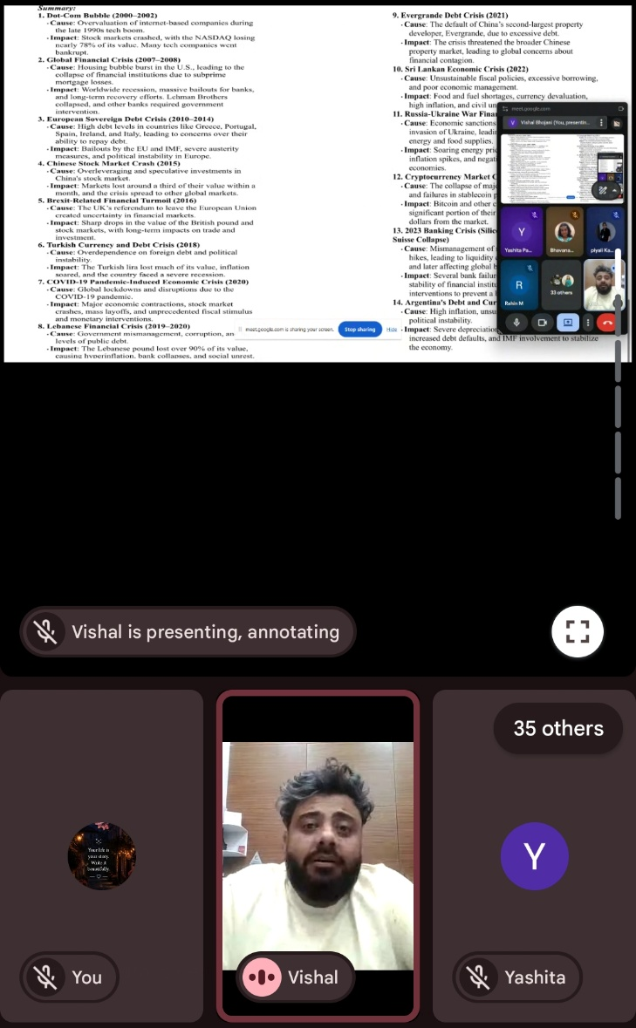
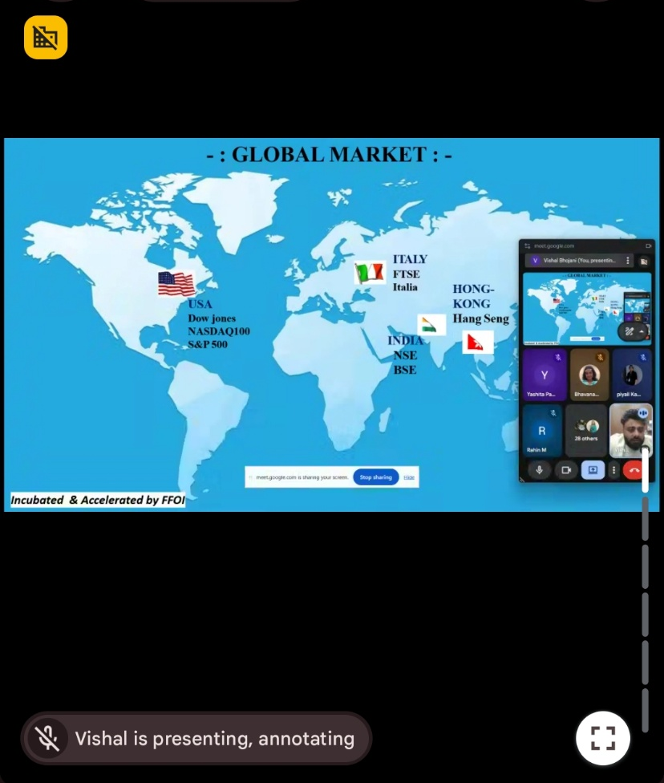

Feedback Analysis:

