ROTRACT CLUB OF mLAC

Partnered by

ROTARY AND ROTARACT BANGALORE EAST

Charter installation ceremony of Rotaract club

Maharani Lakshmi Ammani College for Women, Autonomous

DATE: 10-02-2024
VENUE: Dr. K.N. V. Sastri Auditorium, mLAC

The charter installation ceremony of mLAC took place on February 10, 2024, Saturday at 1:00 pm. The Guests of Honour were Rtn. Shri S.S. Naganand Chairman of mLAC and Rtn. Dr. M.I.M. Nehruzii, Dean of GEMS B school who graced the occasion.

The welcome address was given by the charter president Rtr. Ibbani B.N. followed by state anthem and lighting of the lamp.

Rtn. Dr. M.I.M. Nehruzii gave an insight into about his journey as a Rotarian and enthralled the audience with his motivating speech.

Rtn. Shri S.S. Naganand gave an impressive speech about his experiences when he was a member of Rotary club and community services rendered during his tenure as Vice president.

The President of Rotary Bangalore East Rtn. Rajesh Kumar and the secretary Rtr. Krishna gave
an overview of the genesis of Rotaract East, the projects implemented and they sponsored for 3 tickets for Rotasia which was a great opportunity for our rotaract members. He inspired the Rotaract members to engage in many meaningful community service projects organized through his club.

The gong and gavel were handed over to charter president Rtr. Ibbani B.N. by Rtn. Rajesh Kumar ,, the President of Rotary Bangalore East. Then charter president Ibbani gave the acceptance speech After that the Vice President, Secretary, treasurer and Board of Directors were introduced by the president of Rotaract mLAC and badges were installed by the dignitaries.

Dr. Nagalaxmi B.N., Principal of mLAC expressed happiness about charter installation ceremony of Rotaract club at mLAC and wished Ms. Ibbanni and officer bearers all the best and encouraged them to be part of community service programs and spread the message of oneness among student community.

Vice Principal Prof. Sharmistha Dutta, CAO Mr. Gangadarmurthy, Finance officer Mr Narayana Subramani and the IQAC Coordinator Prof. Aruna H.K. and Ms . Thanushree V.L , Assistant
Professor also wished the Rotaract mLAC team all the best for their future endeavours.

The Secretary gave a report on the upcoming project and the events for the year of 2023-24 and highlighted about the project “depression mukt” where Rotaract mLAC had associated. Rotaract secretary Rtn. Nikitha N proposed vote of thanks . The ended with the national anthem.

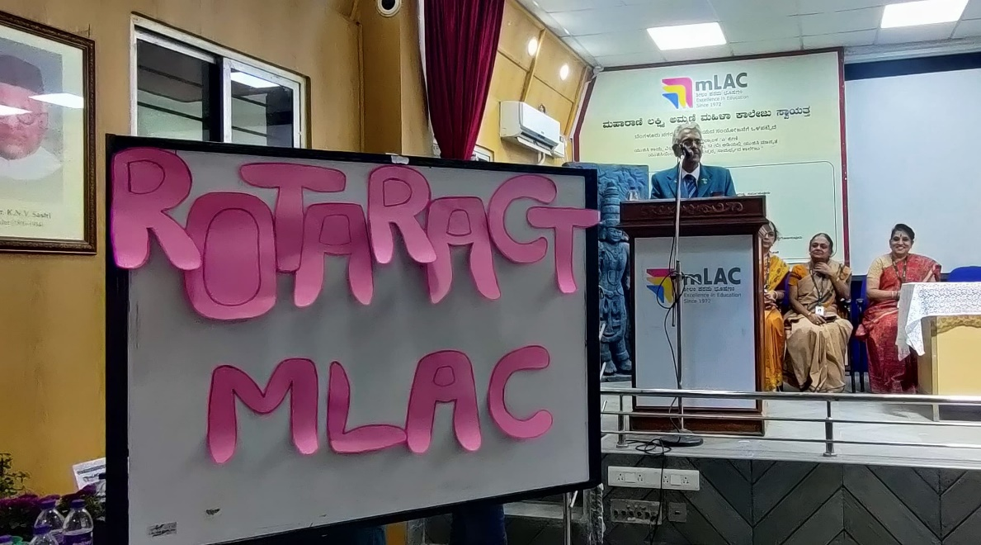

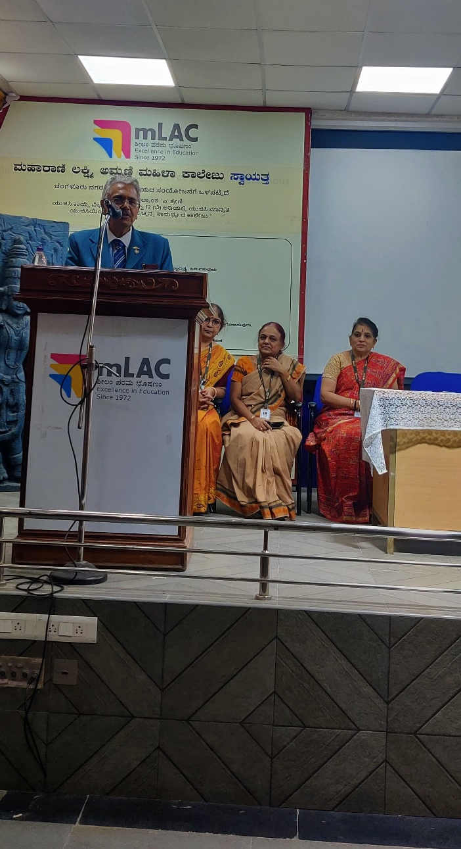

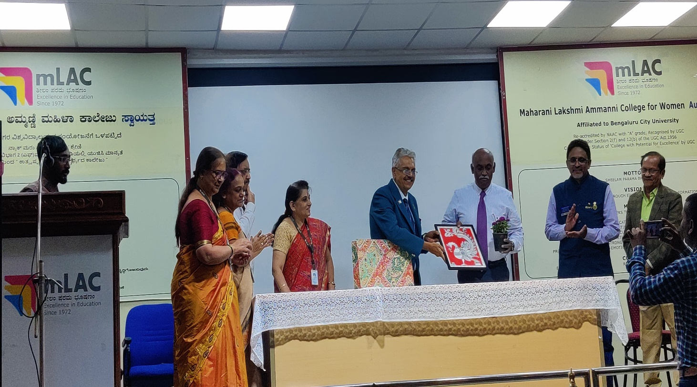
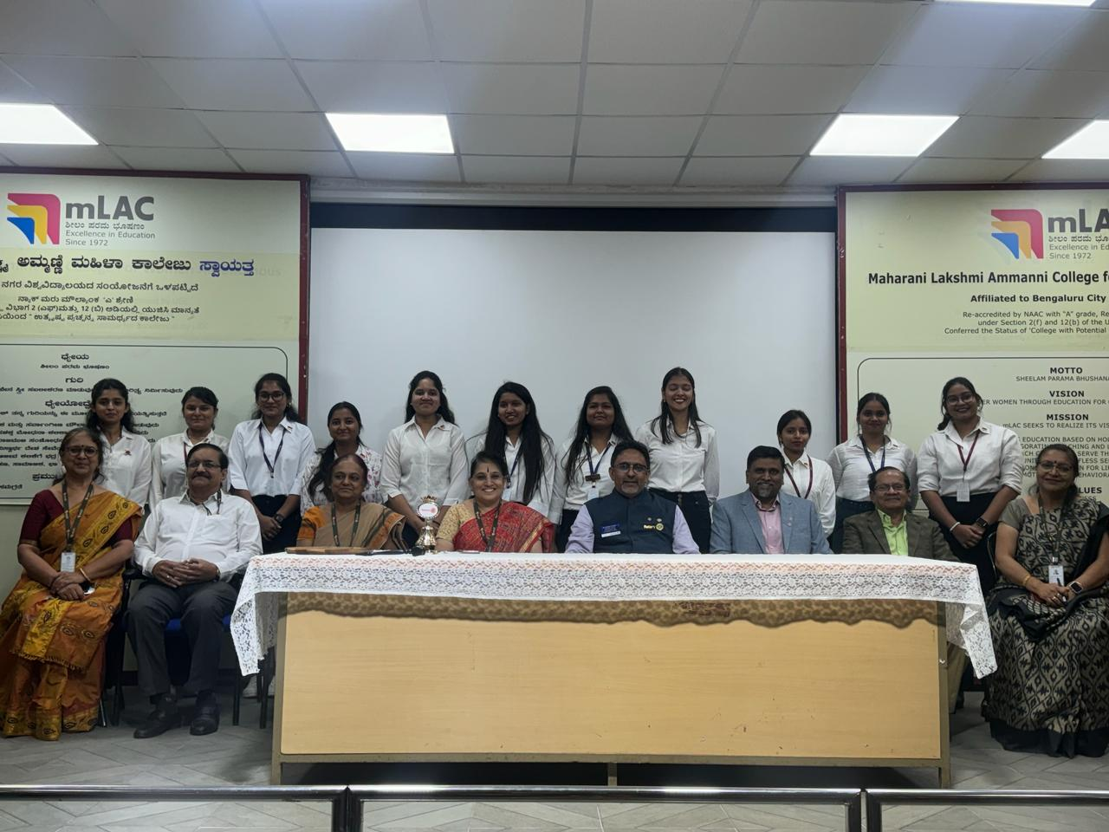

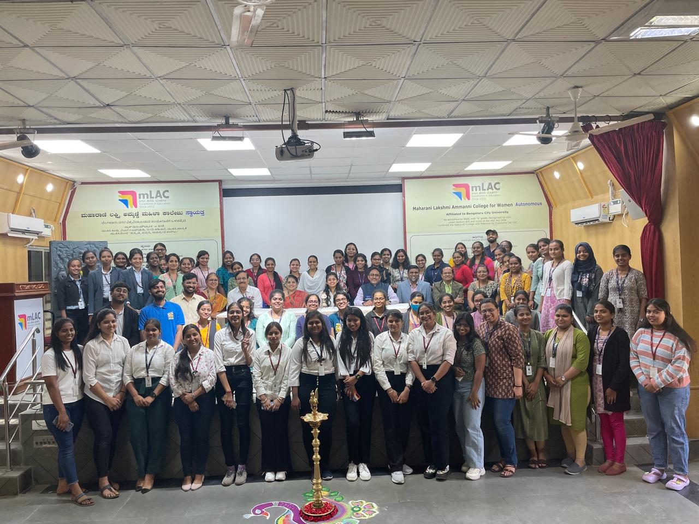

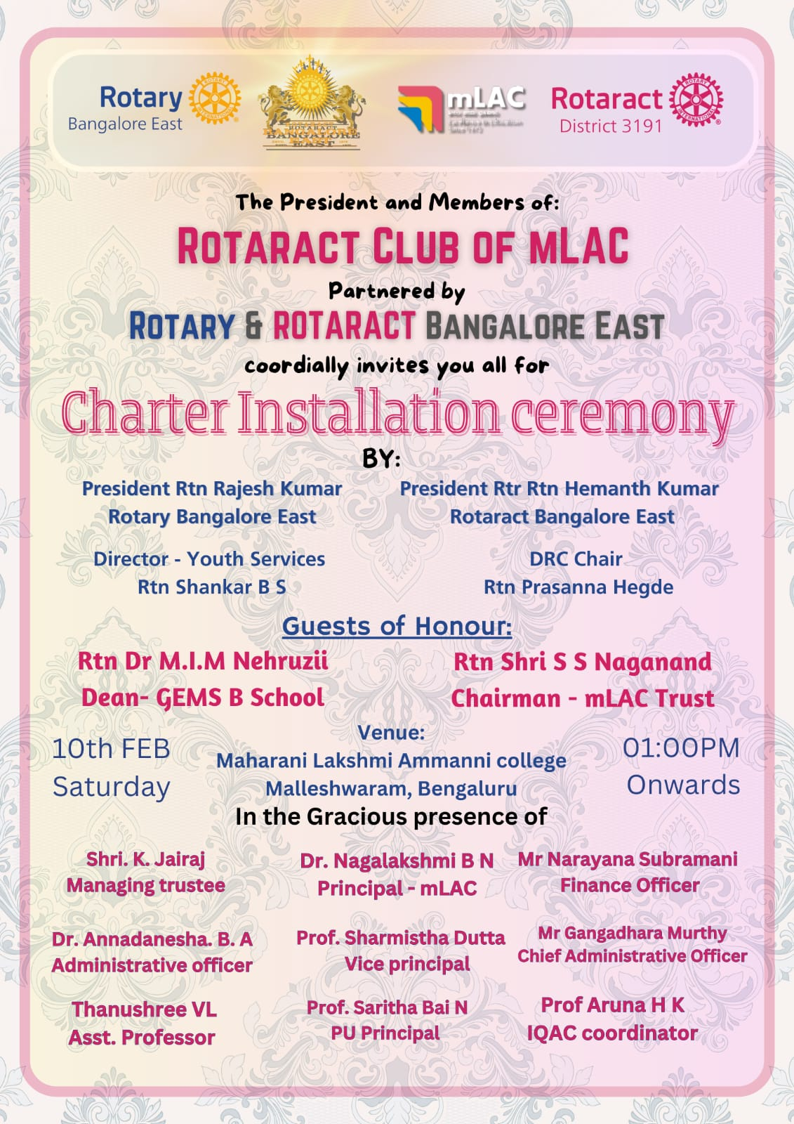

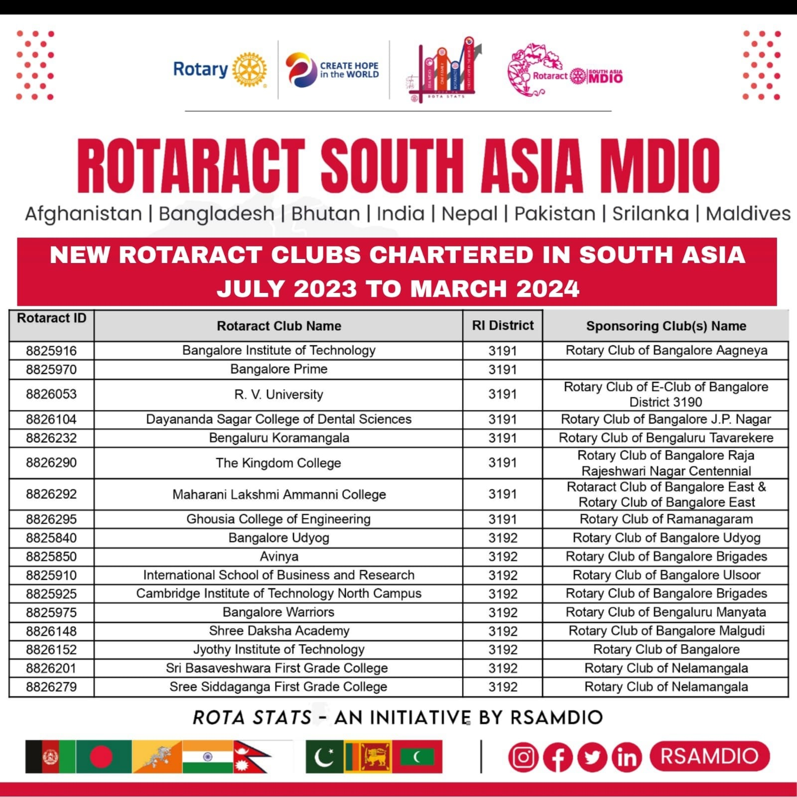
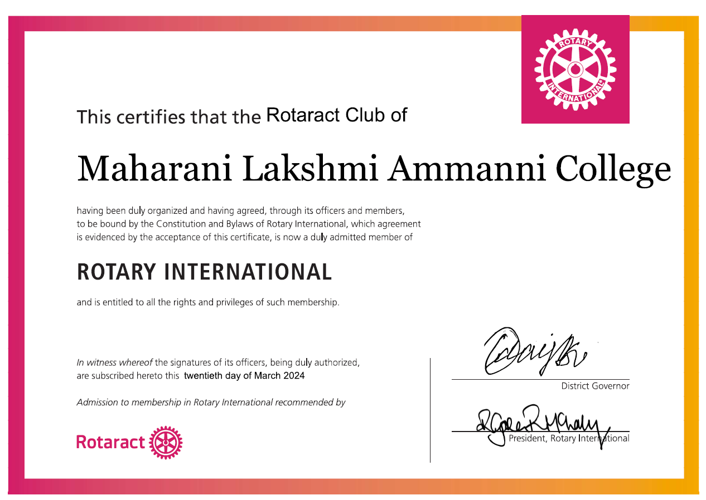

Report on “Depression mukt” project

Date: 26/11/2023 Venue: Malleshwaram

On 26th November 2023, a movement to bring happiness to street vendors and others in and around Malleswaram, Bangalore, was organized under the project depression mukt . Students from Rotaract Club of mLAC participated in this project. It was the program for Rotract club members to interact with people and encourage them to speak about their stress and worries.
Initially Rotract members were introduced with the interact club and Rotaract club president Rtn. Hemanth Kumar from Rorary East. He briefed the participants about the service to the club and society.
The interaction enabled the people to reminisce their goals and dreams. And connect their past to the present situation.
At the end of the program, the group members assembled at a point and discussed their experiences and sharing their experiences. This was a great learning experience for newly Rotaract members to understand the life experiences which takes unexpected turns and preparedness by everyone to face the world with gratitude.
“Service to others is the rent you pay for your room here on earth”
